ACADEMIC YEAR
2024-2025
EVEN SEM
NEWS LETTER
FEB 2025 – JUNE 2025

06-02-2025 TO 20-02-2025
INTERNSHIP conducted by V V ELECTRO SYSTEMS for III Year EEE Students
1.HEMARAJ.R
2.LOGENDHERAN.R
3.SANJAY.U
4.SURYA PRAKASH.T
5.AVINASH.K
6.GOPIRAJ.M
7.SAKTHIVEL.V
8.SAMURL.R
9.SANTHOSH.M
10.KAVIYA SRI.S
11.NAGESHWARI.R
12.SANDHIYA.A.S
13.KALAISELVI.P
14.OVIYA.R
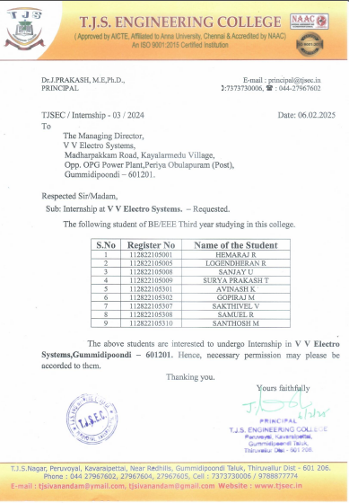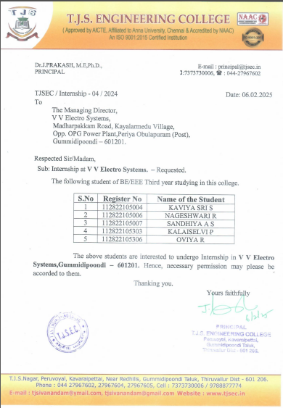

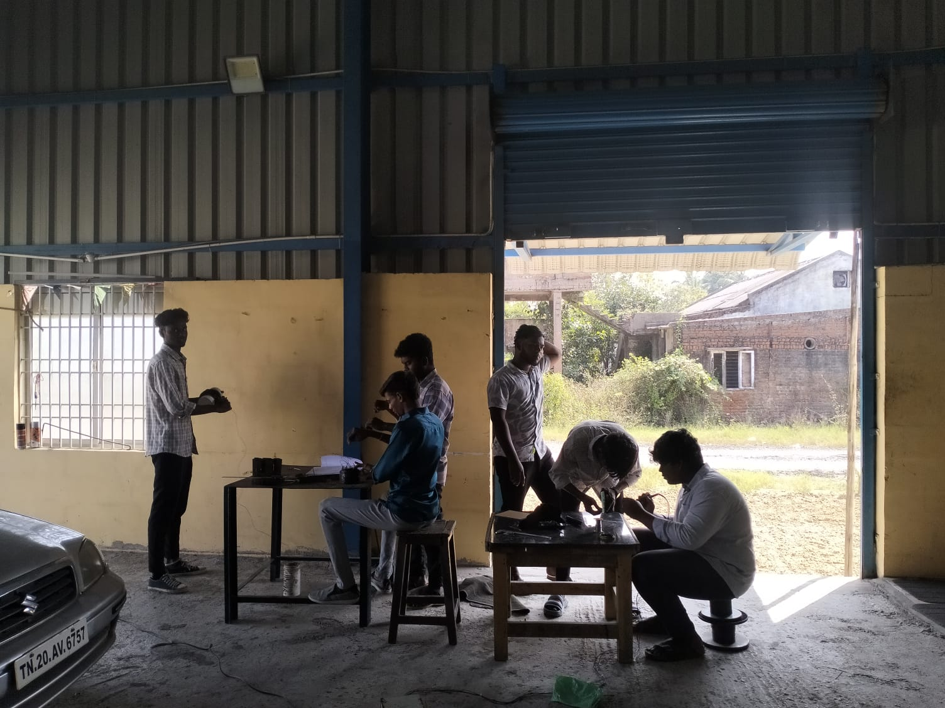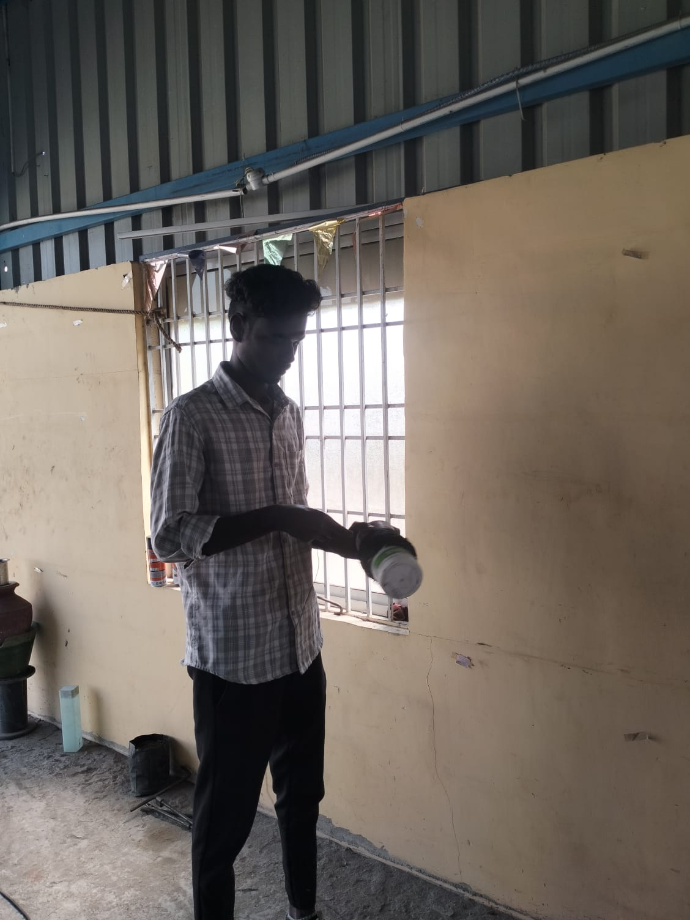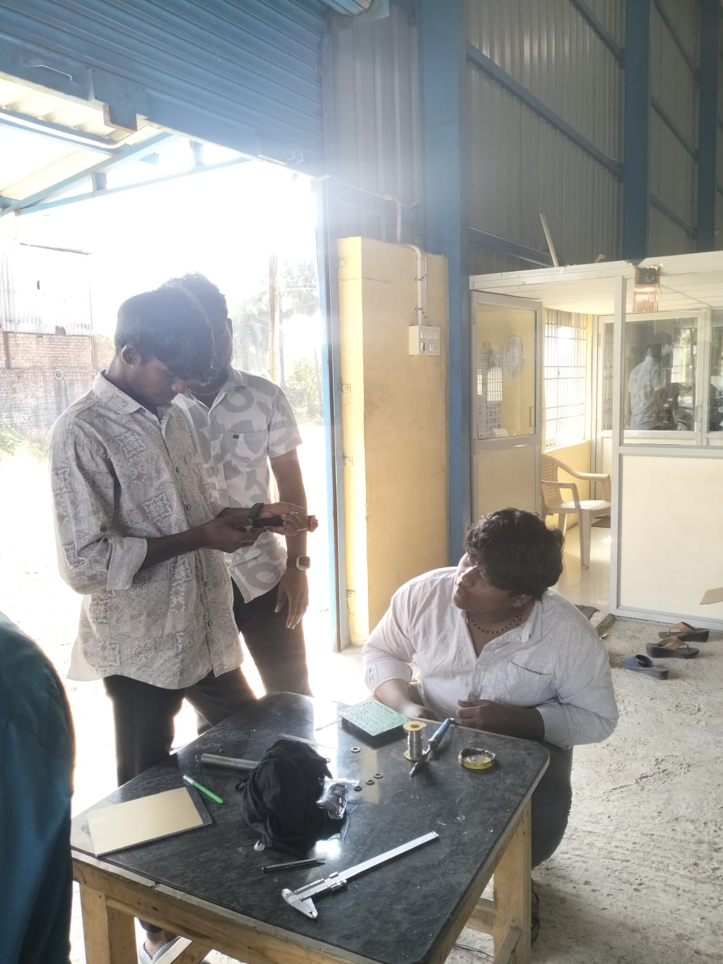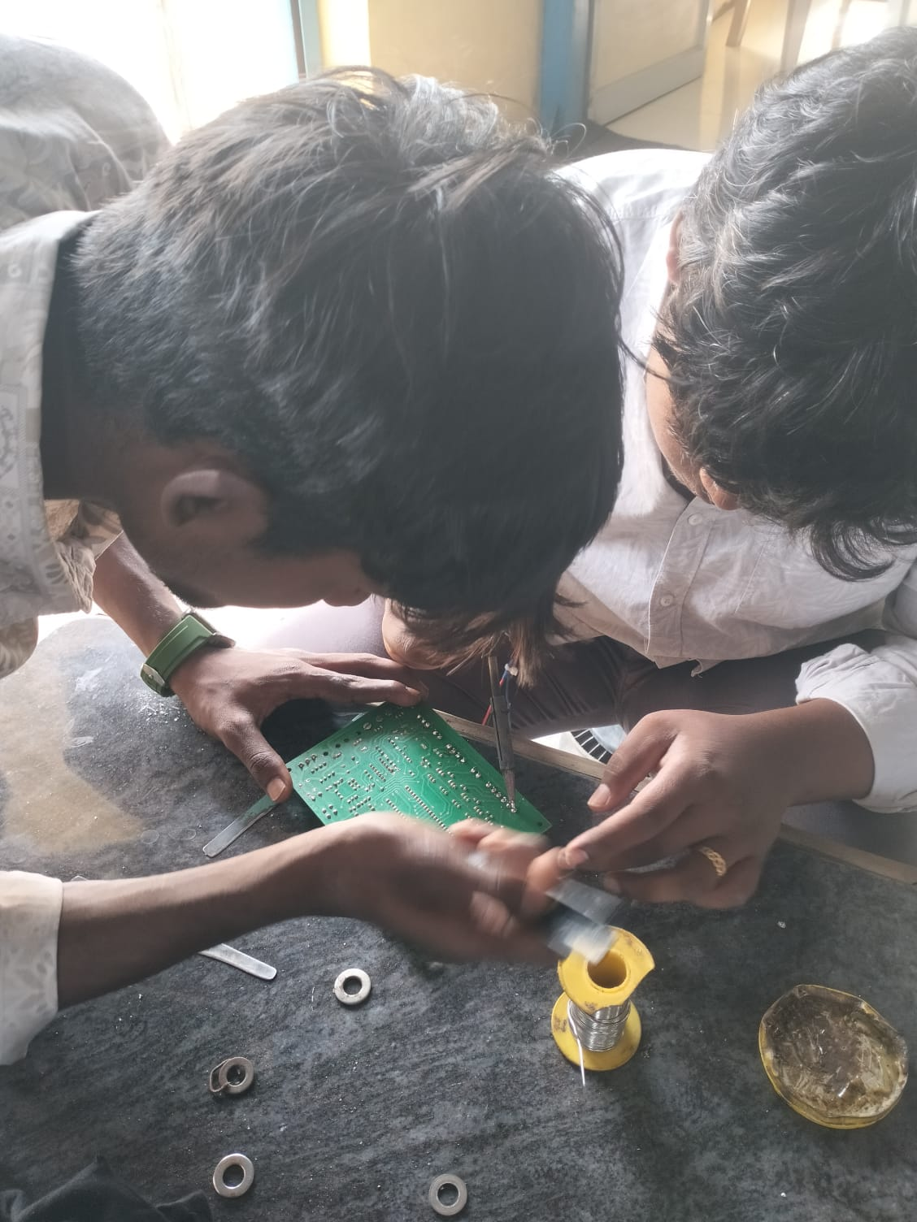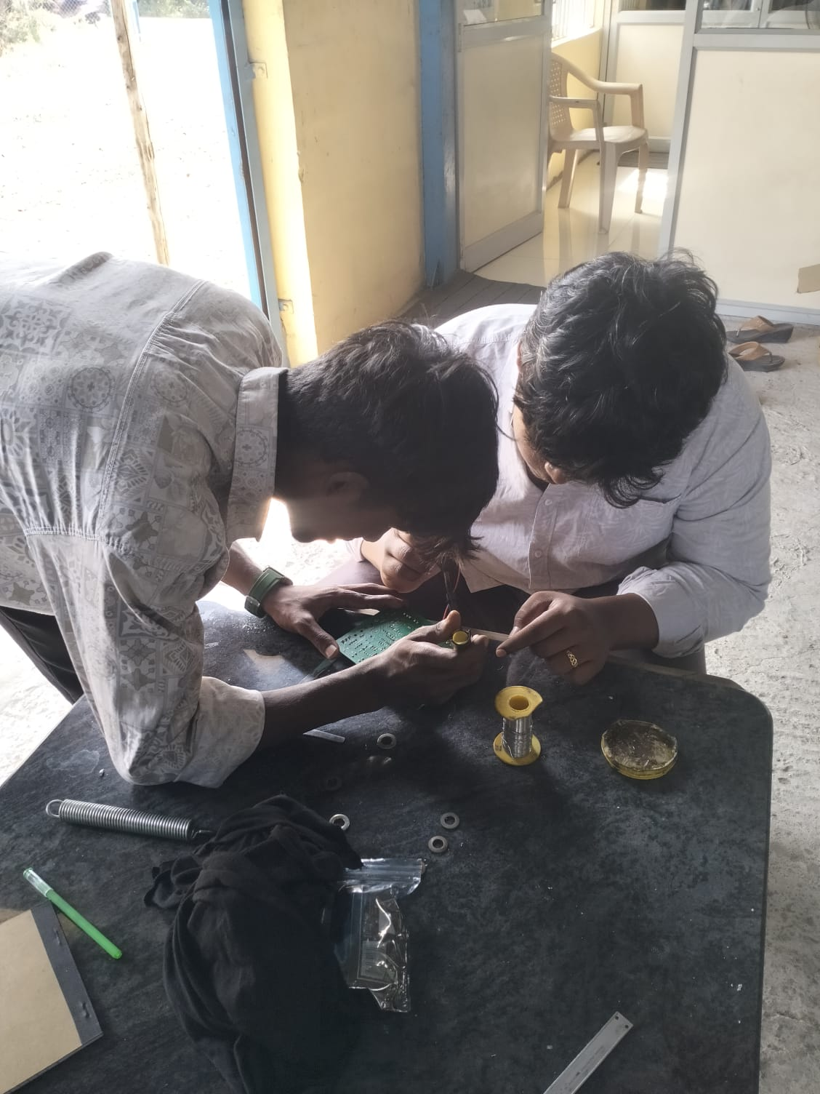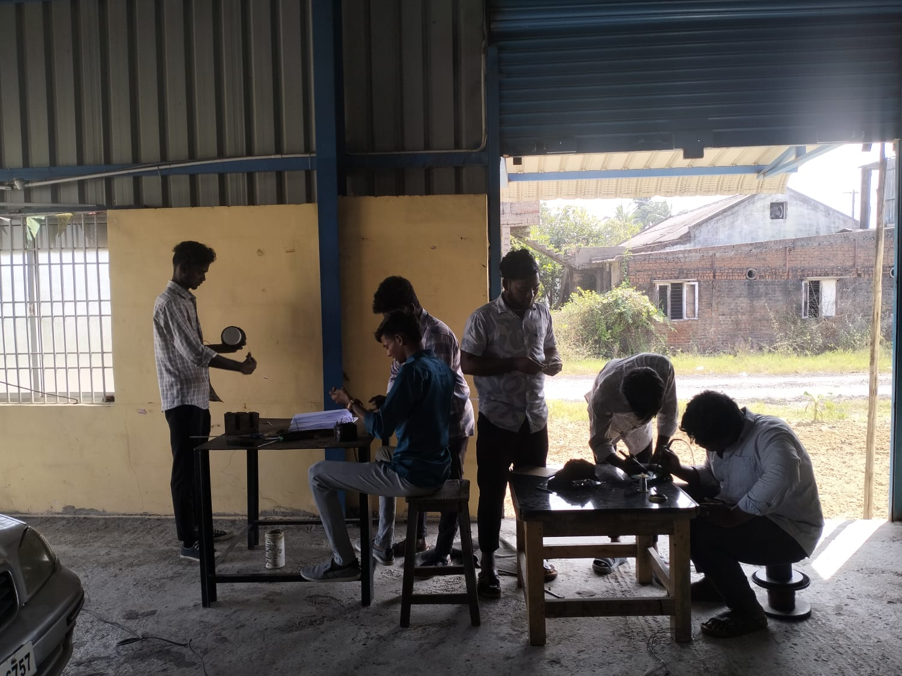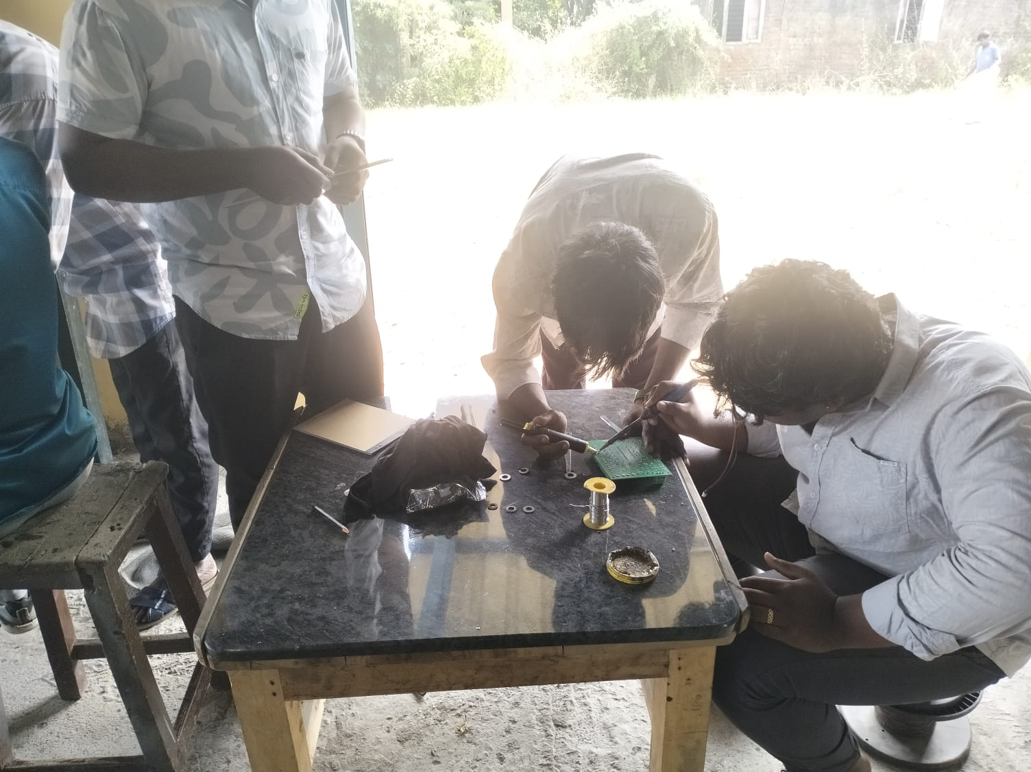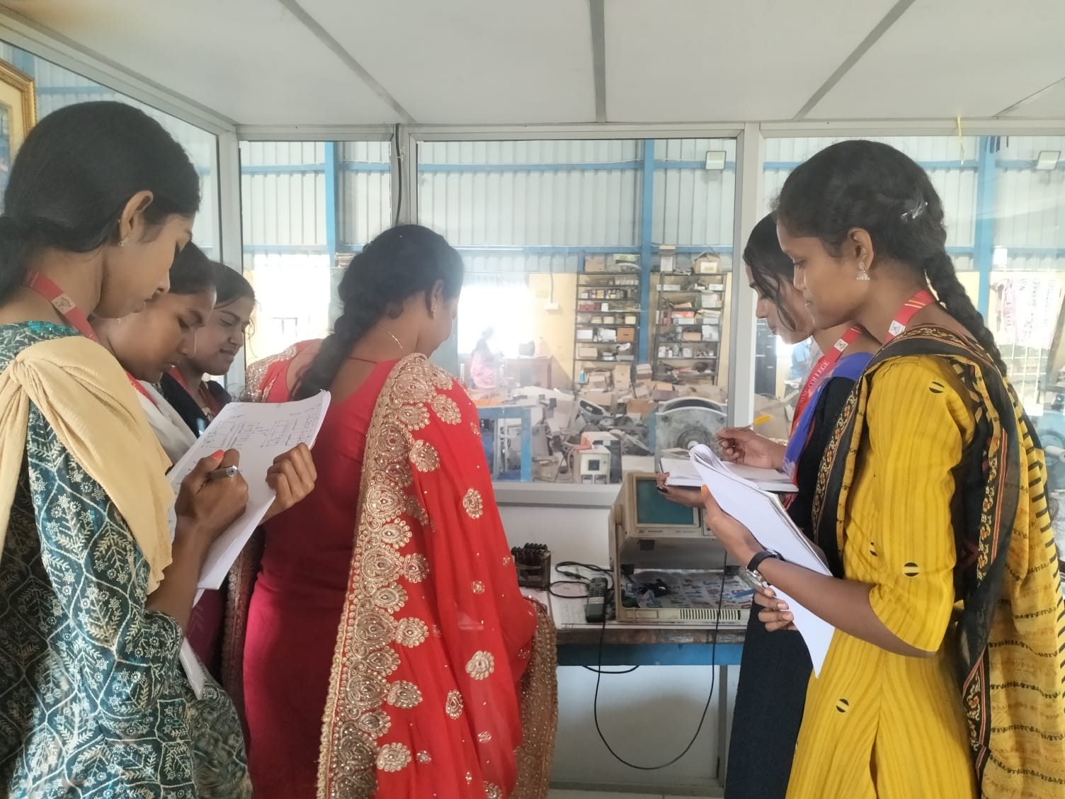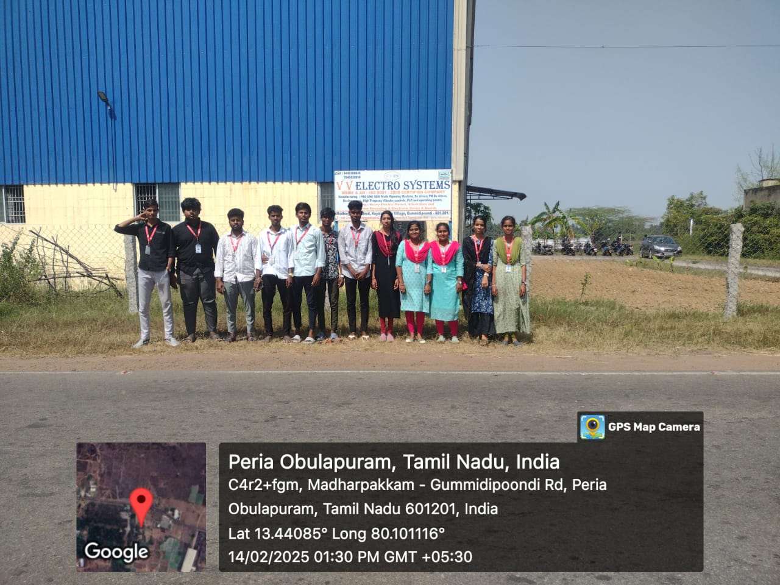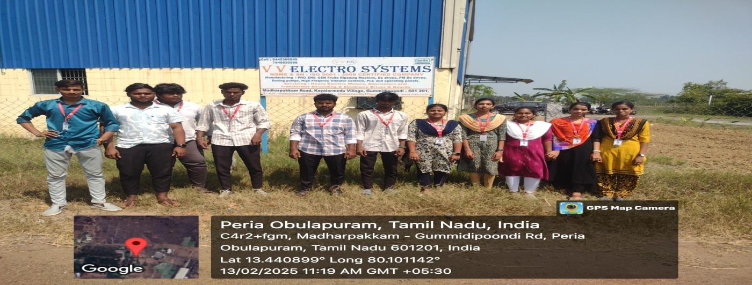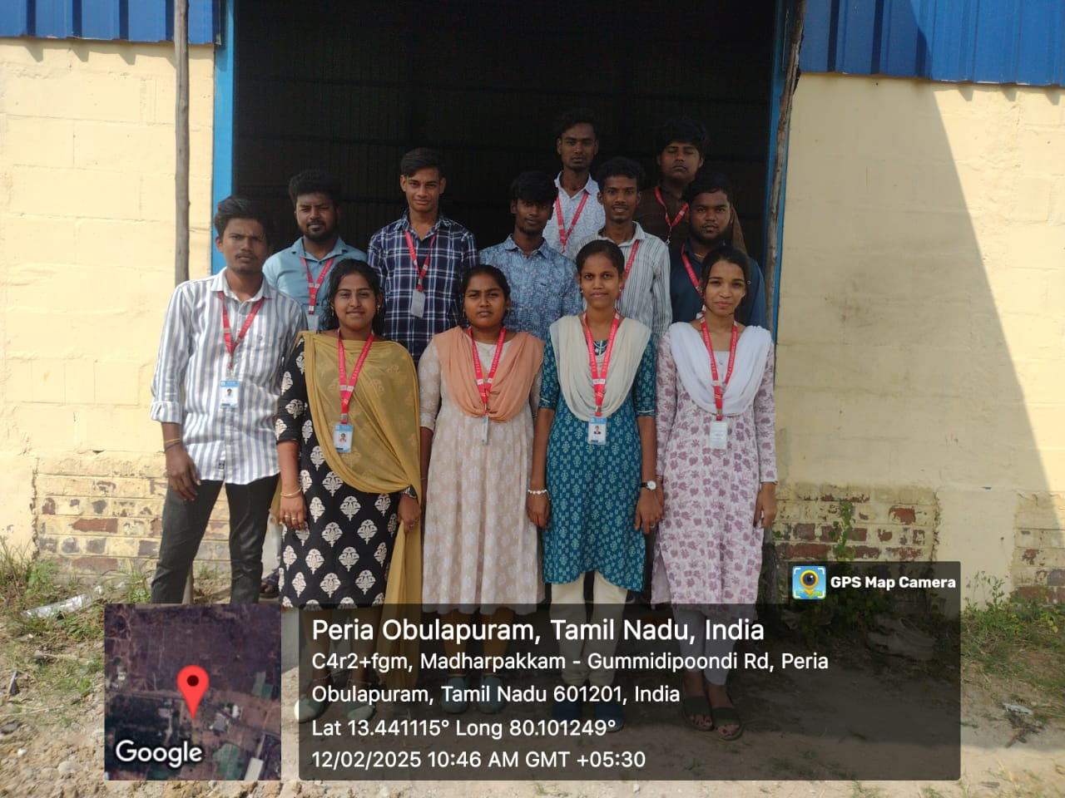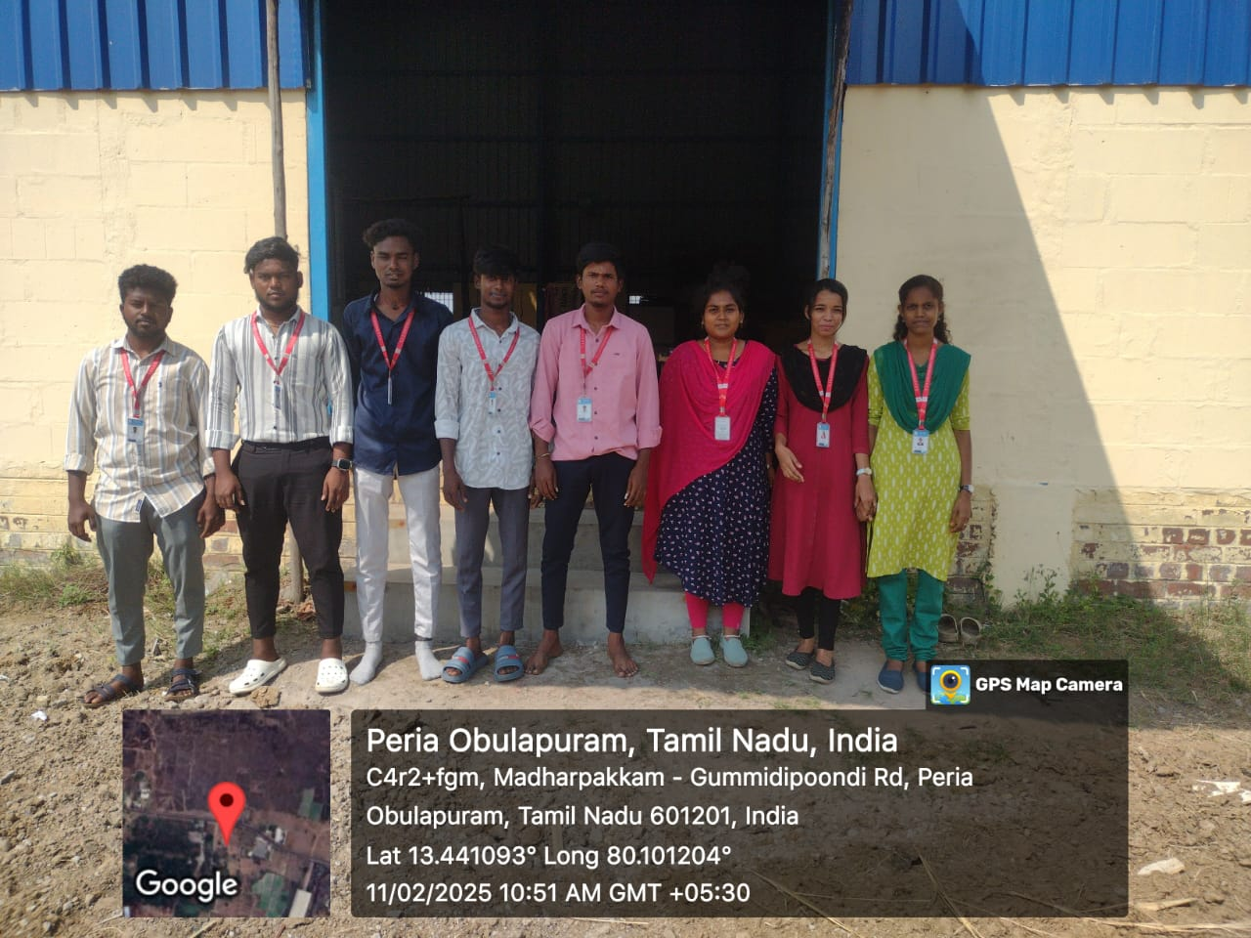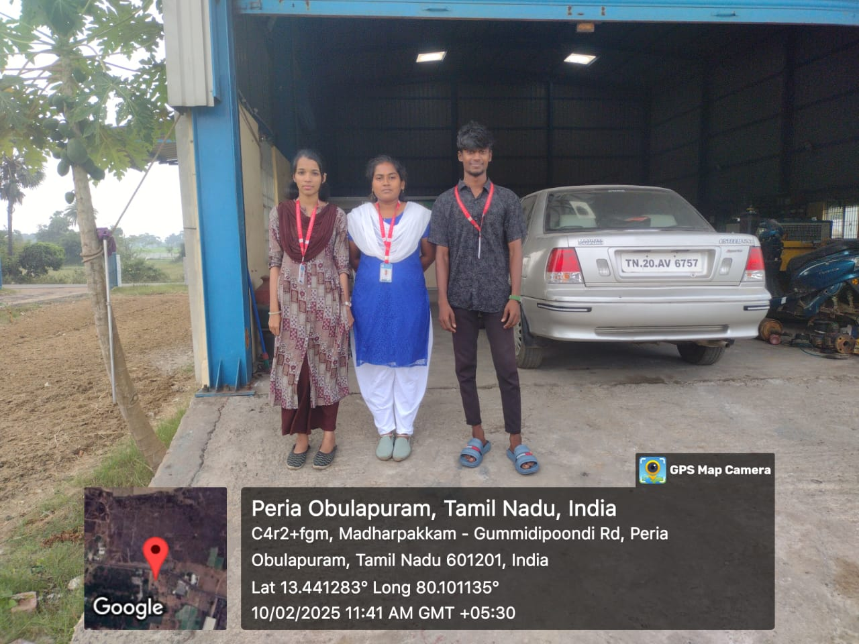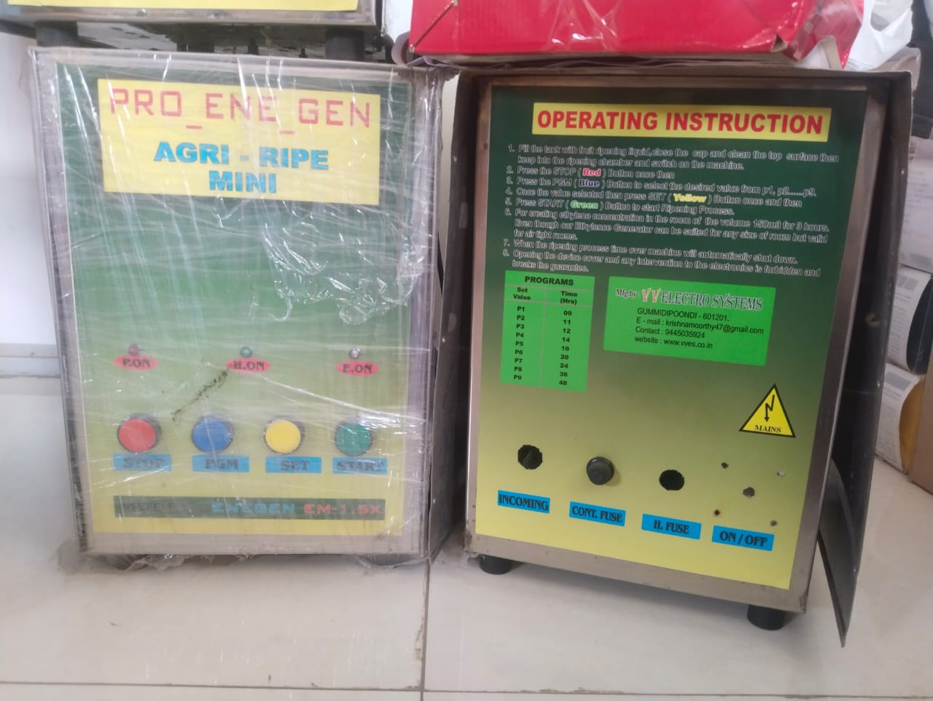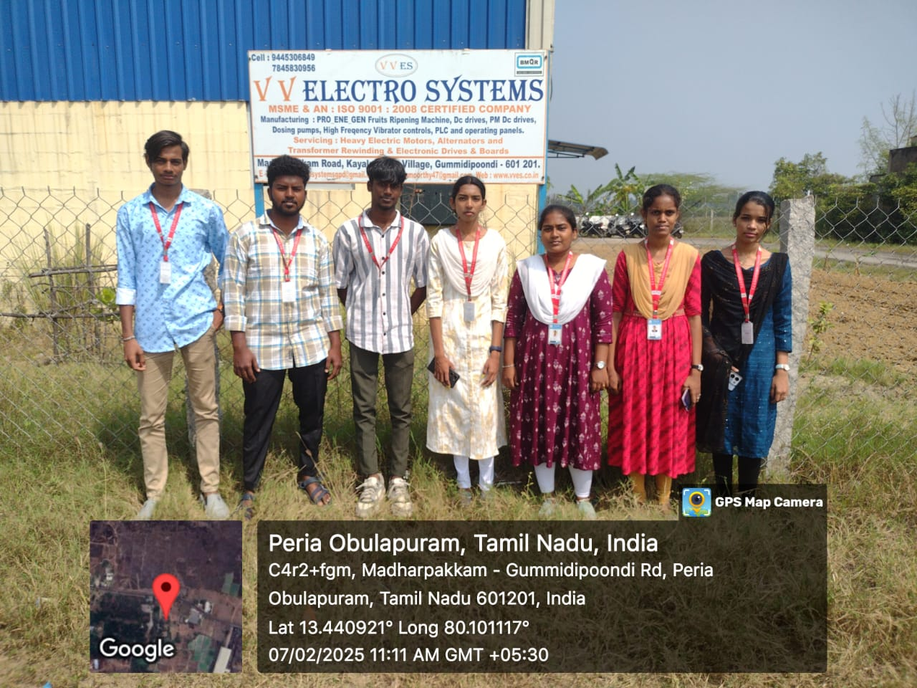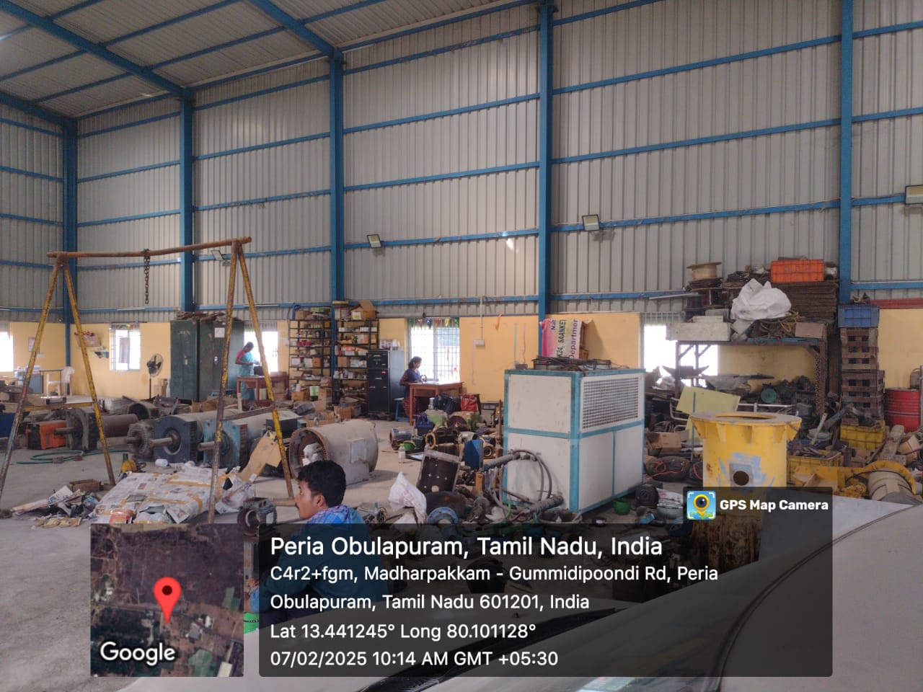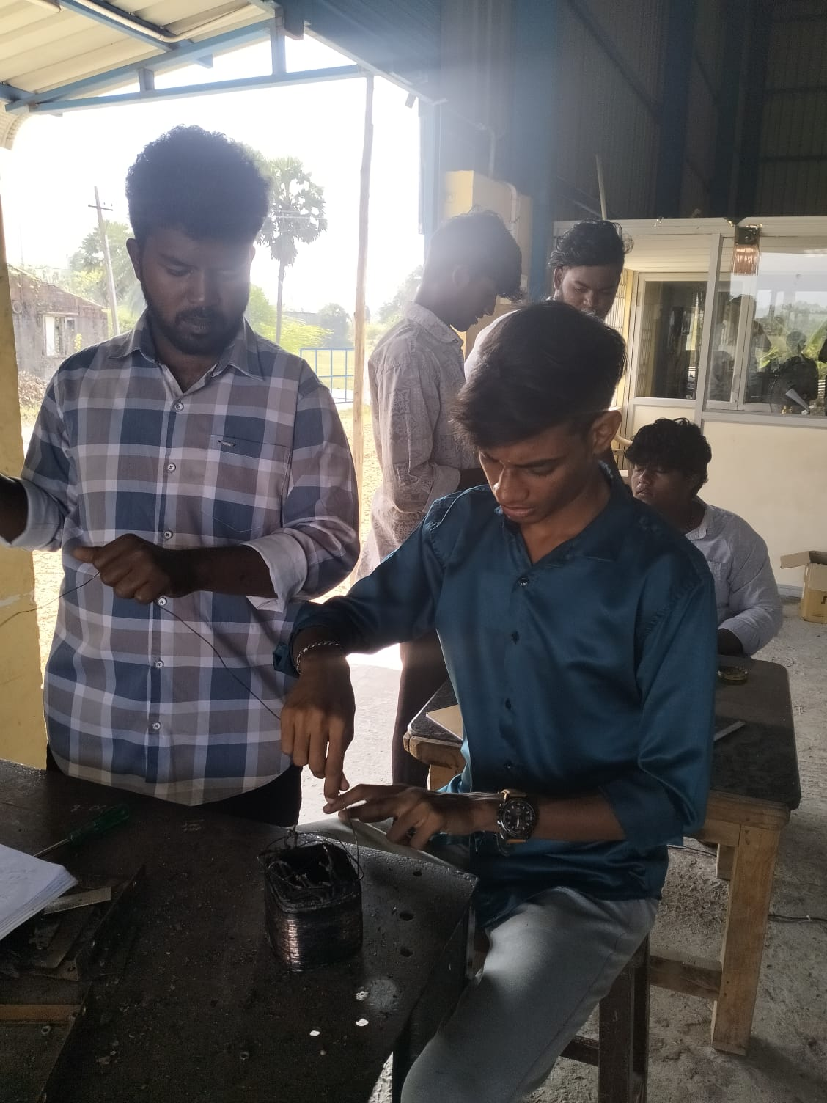

12-02-2025 TO 11-04-2025
INTERNSHIP conducted by Indian Institute of Technology (IIT,Madras) for IV Year EEE Students
1.VAYULURU MOULI
2.UDHAYAKUMARAN B
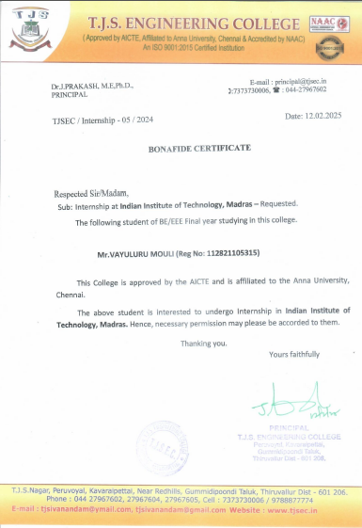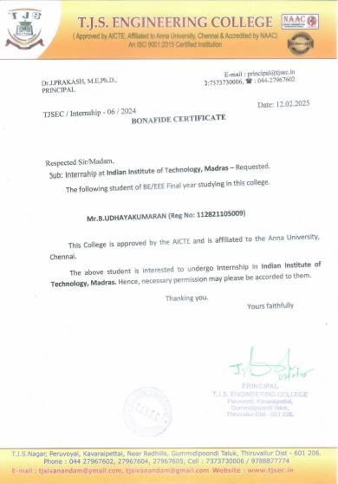

31-01-2025

Mrs.Shunmuga Sankari M with Trainer ID - TR176420 has successfully cleared the assessment as Trainer with Grade 'B' for the Qualification Pack of Hydrogen Plant Technician (Installation, Commissioning and Maintenance) conforming to National Skill Qualification Framework Level – 4

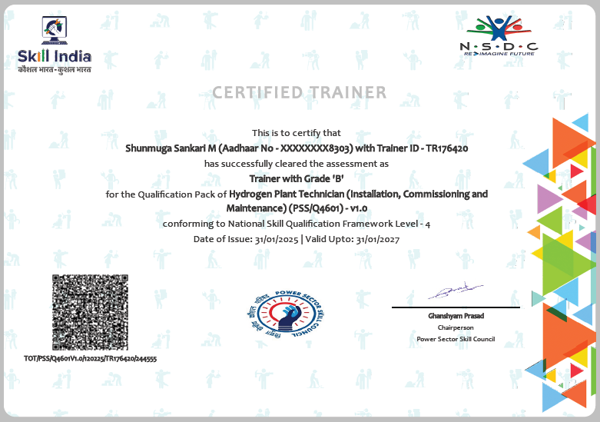

27.01.2025 TO 01.02.2025
FDP organized by ATAL – SREE SAKTHI ENGINEERING COLLEGE on “The Future of Smart Mobility -Integrating AI and IoT in Electric Vehicle Ecosystems “ attended by
Mrs.M.Shunmuga Sankari – HOD/EEE
Mr.T.Kamalkumar – AP/EEE
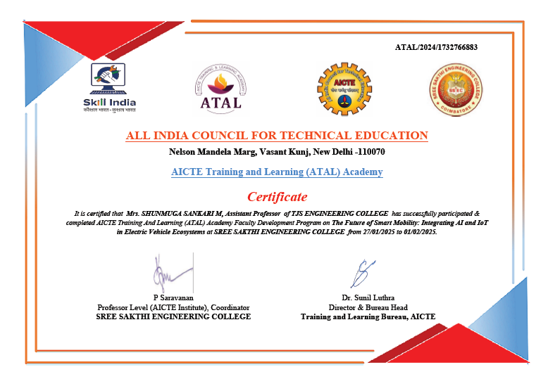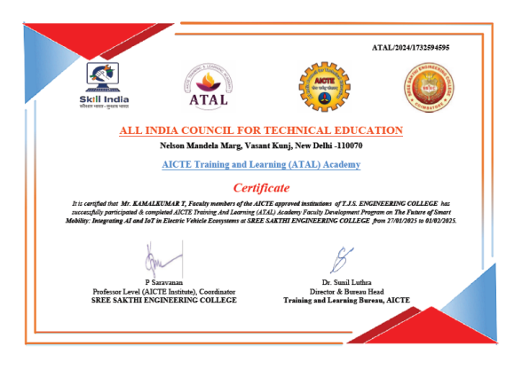

14-02-2025

Mitsuba India Pvt. Ltd. Conducted Blood Donation Camp in T.J.S. Arts & Science College,Peruvoyal. Our II year students donated blood are listed below:

- LINGESHWARAN N (112823105015
- PERARASU K (112823105016)
- VIJAYAKUMAR V (112823105018)

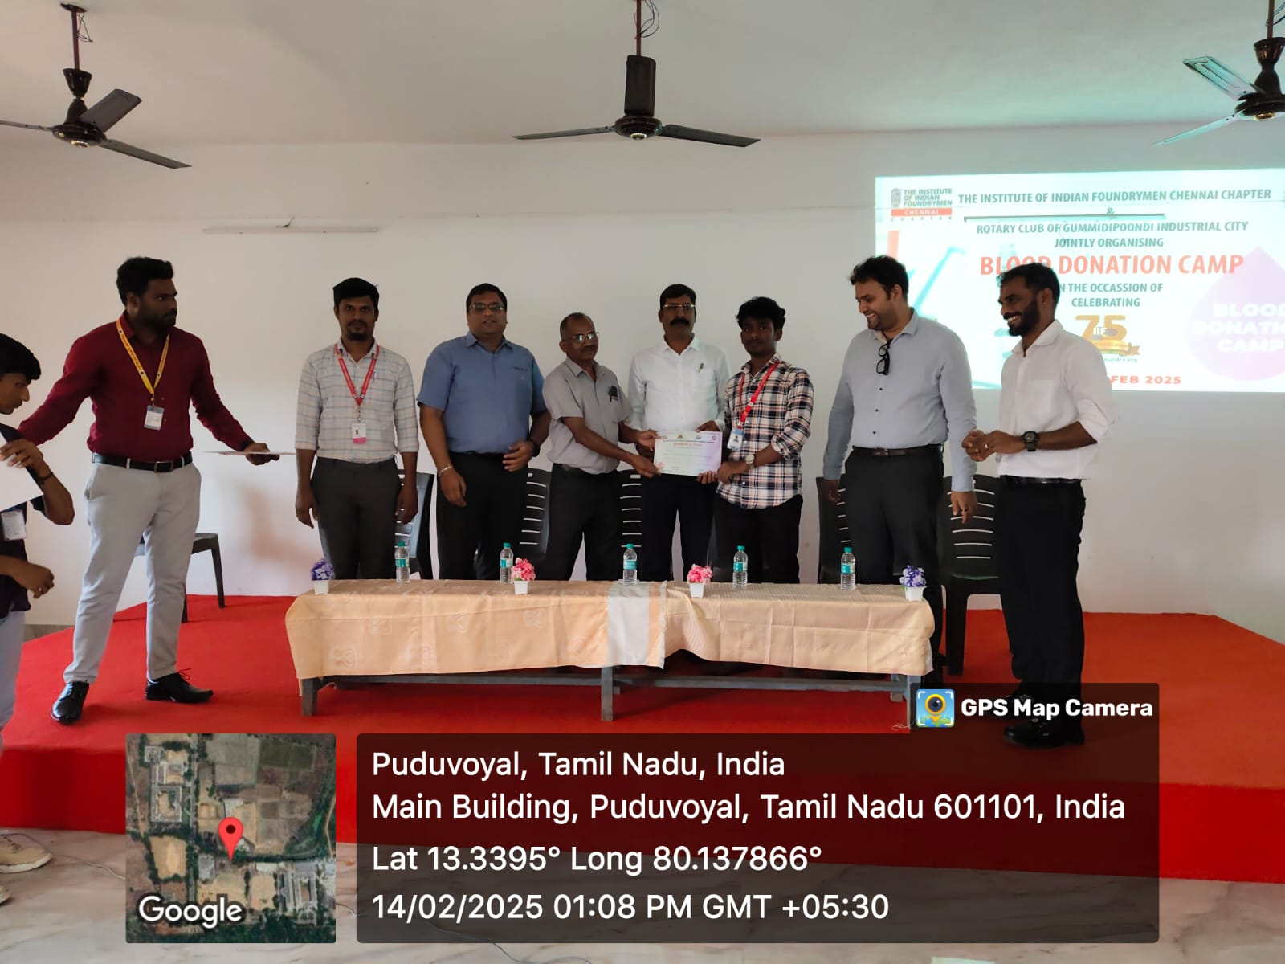
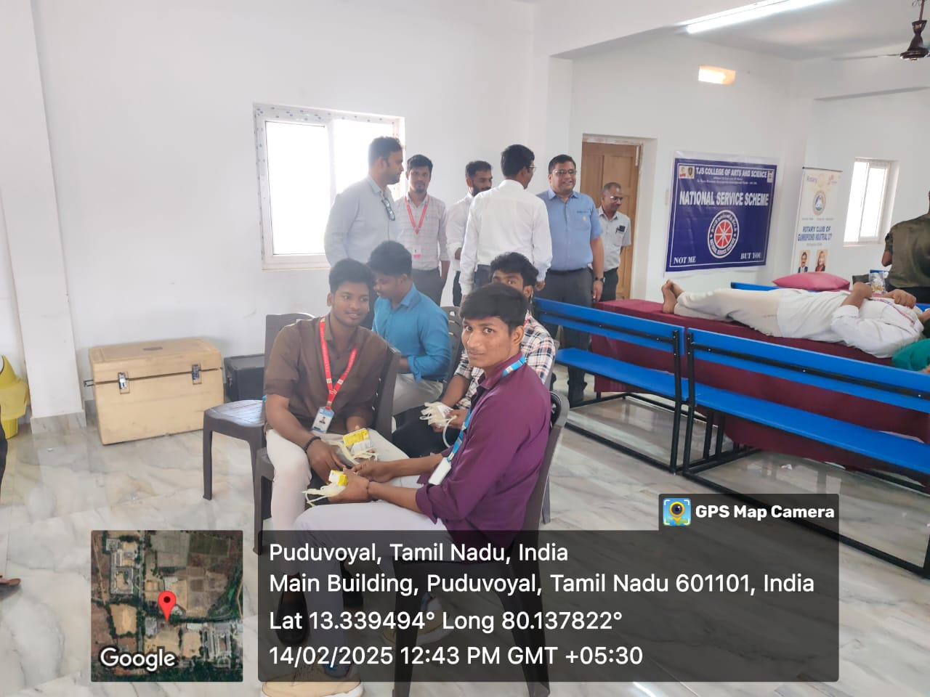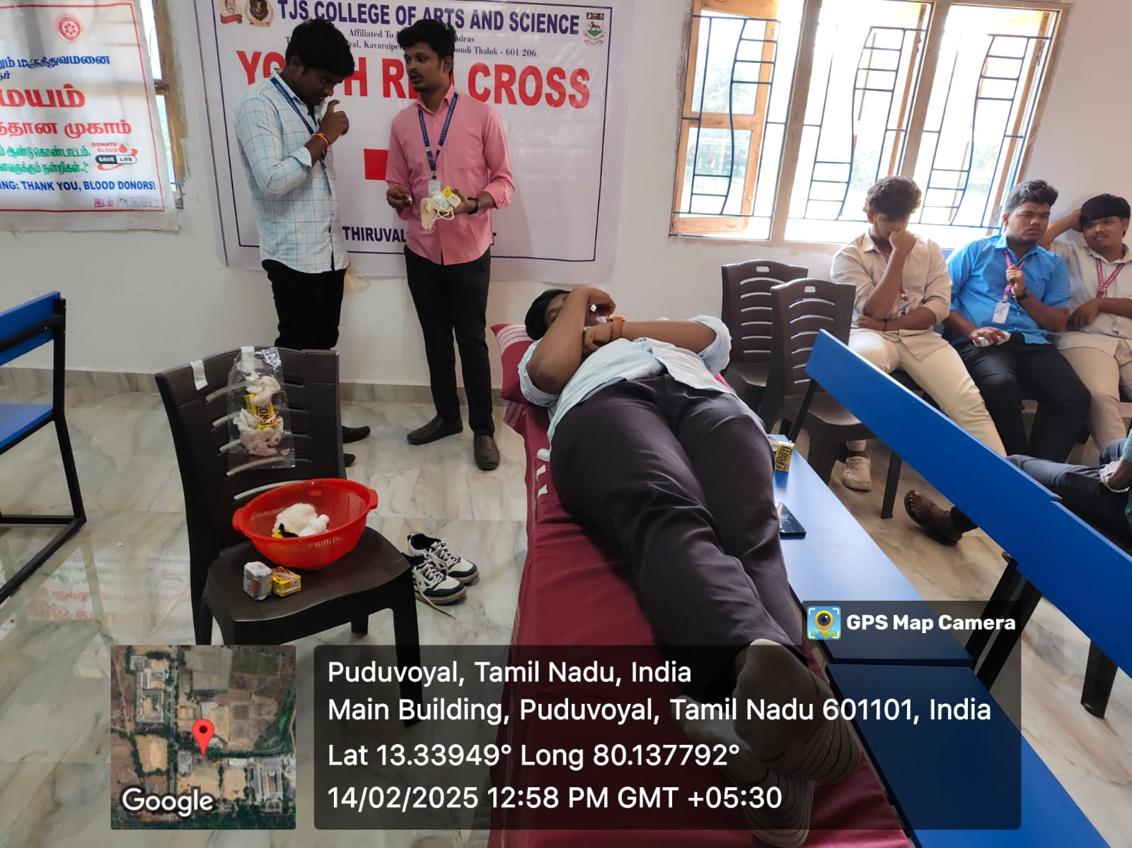

10/02/2025 TO 15/02/2025
FDP organized by ATAL – K RAMAKRISHNAN COLLEGE OF TECHNOLOGY on “The Role of Artificial Intelligence and Machine Learning in Electric Vehicle Technology “ attended by

Mrs.M.Shunmuga Sankari – HOD/EEE
Mr.T.Kamalkumar – AP/EEE
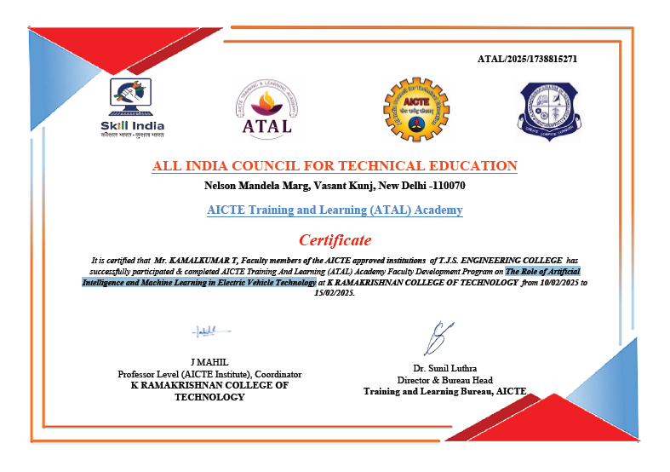
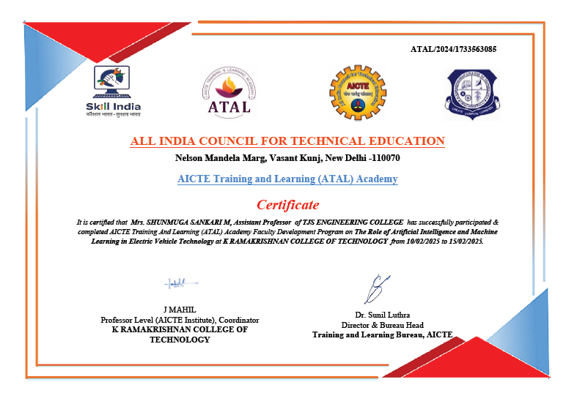
10-02-2025 TO 16-02-2025
FDP organized by NAAN MUDHALVAN for the program “E-Vehicle Fundamentals” on University College of Villupuram attended by Mr. M. Arjunkumar – AP/EEE and “EV Technology for EEE” on Anna University, Guindy attended by Mr. S. Ganesh – AP/EEE
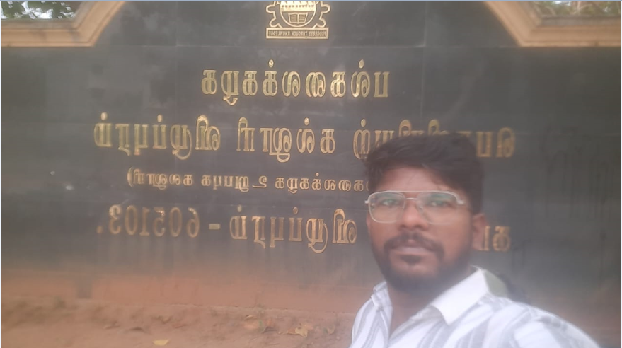
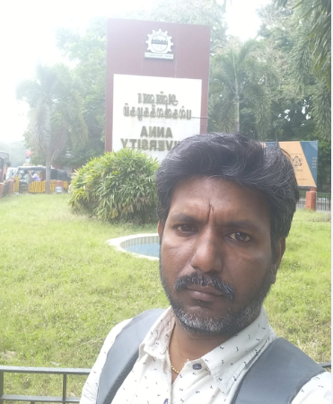
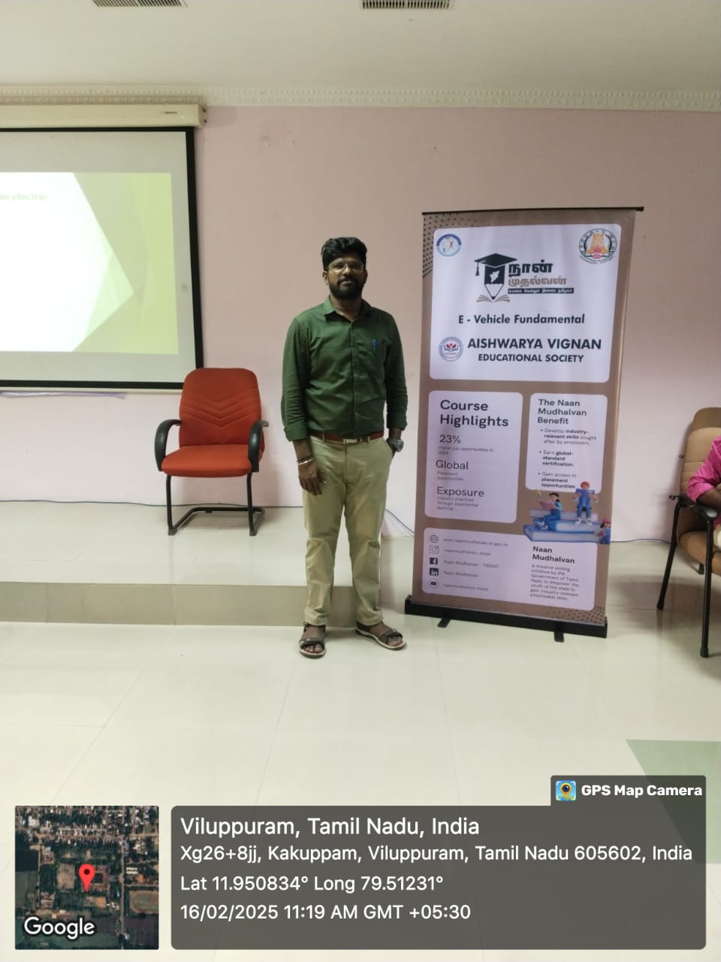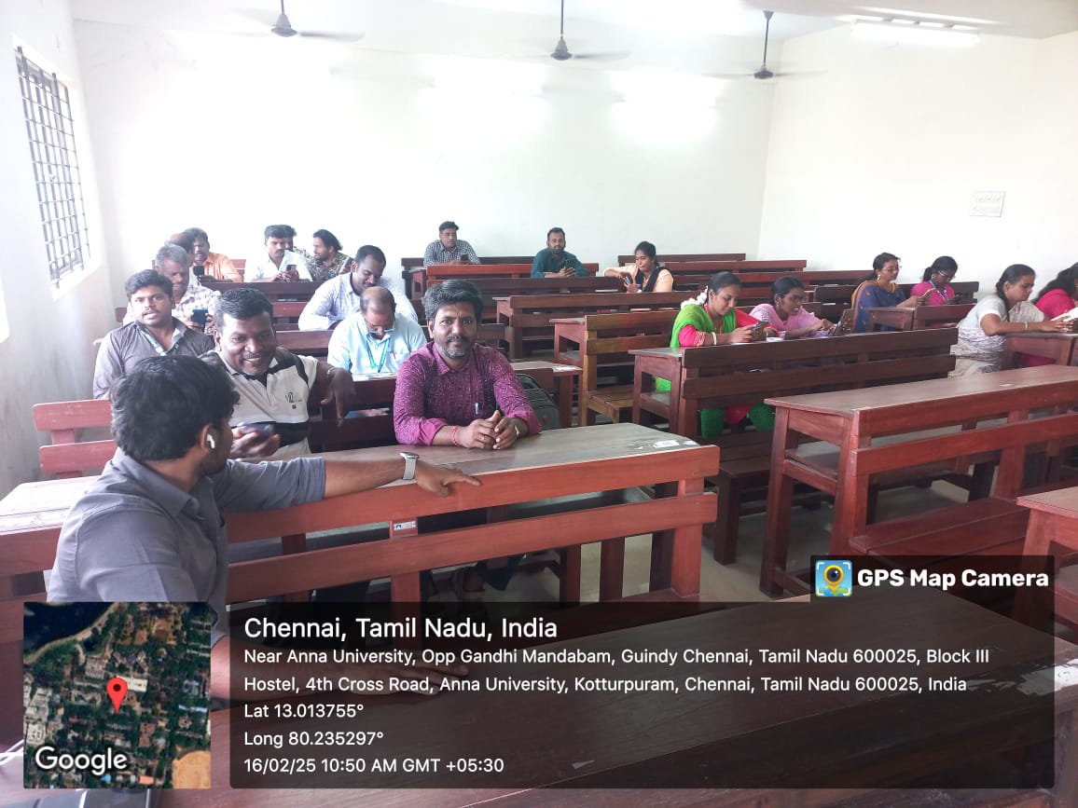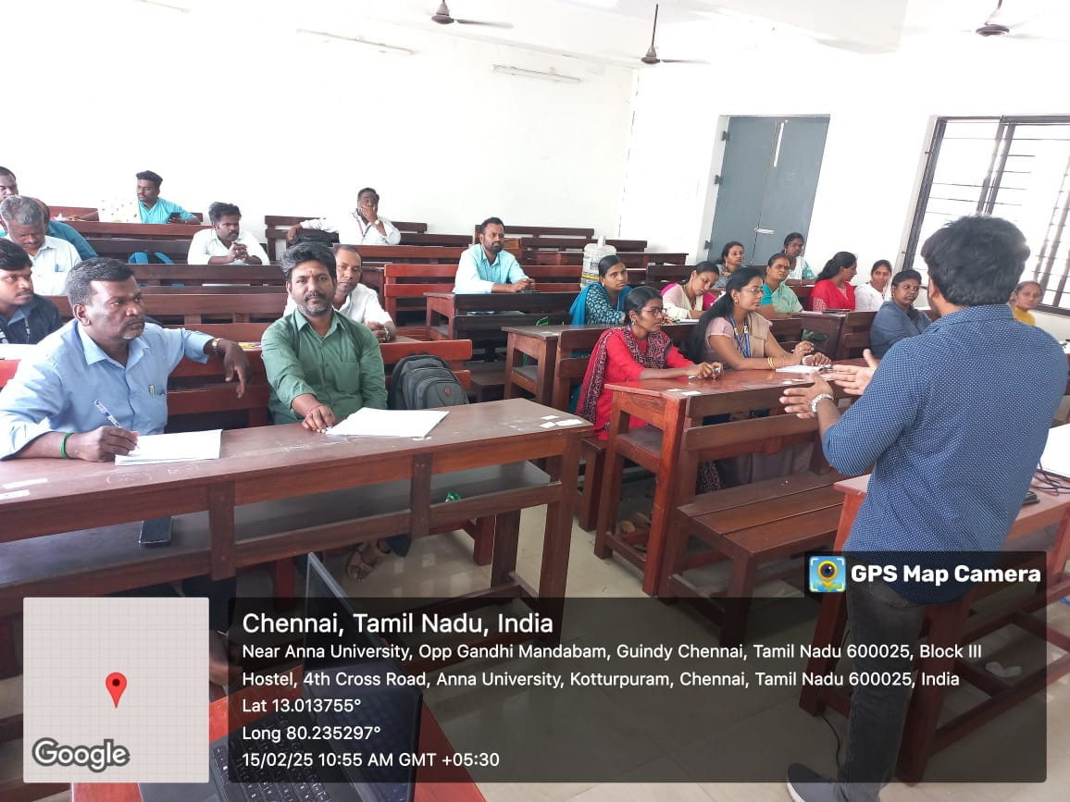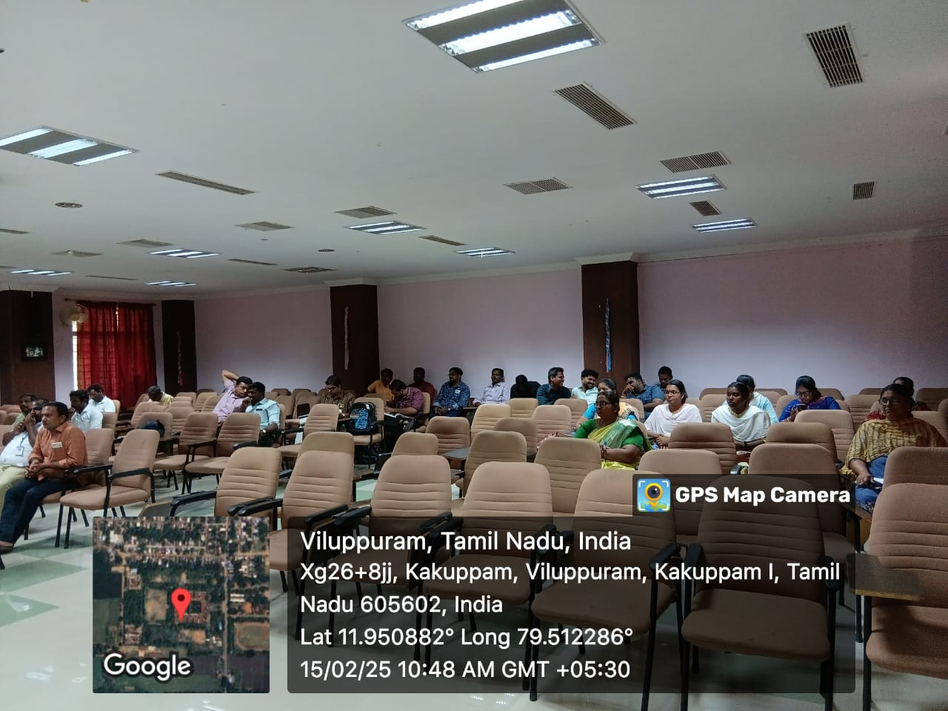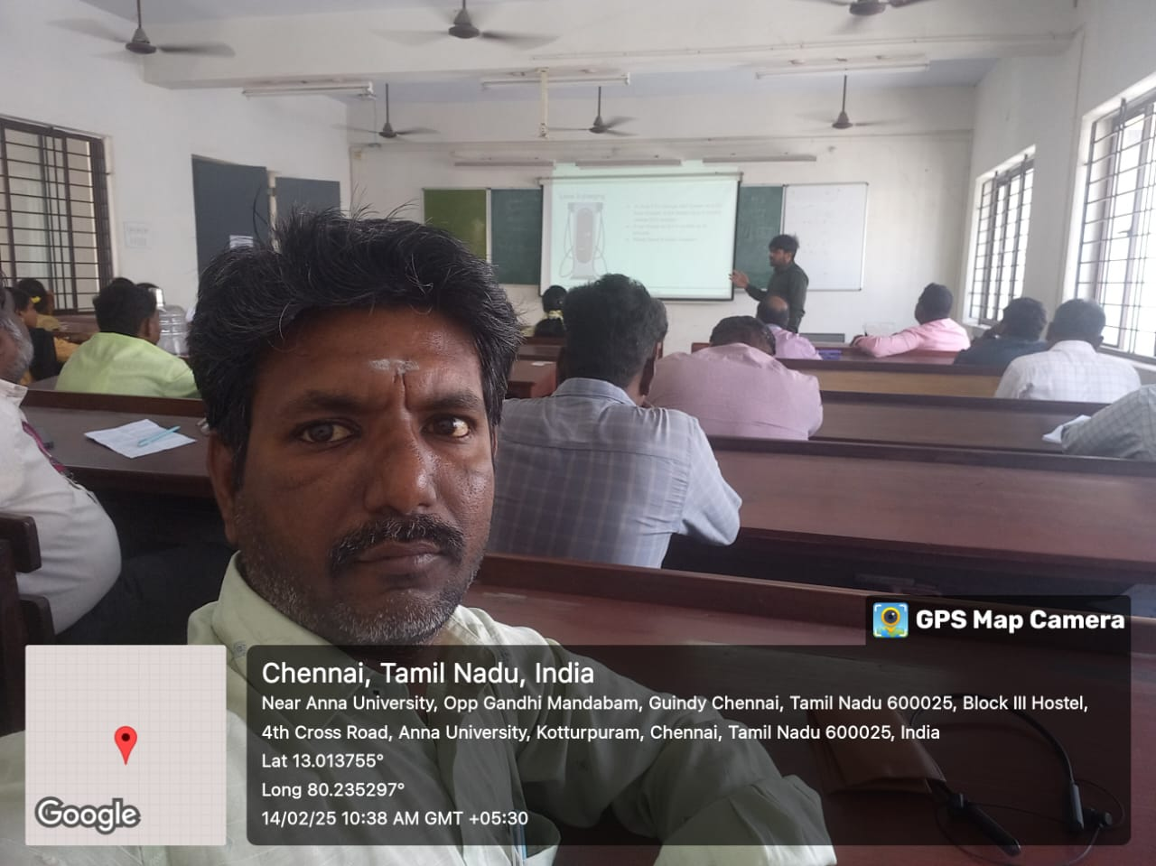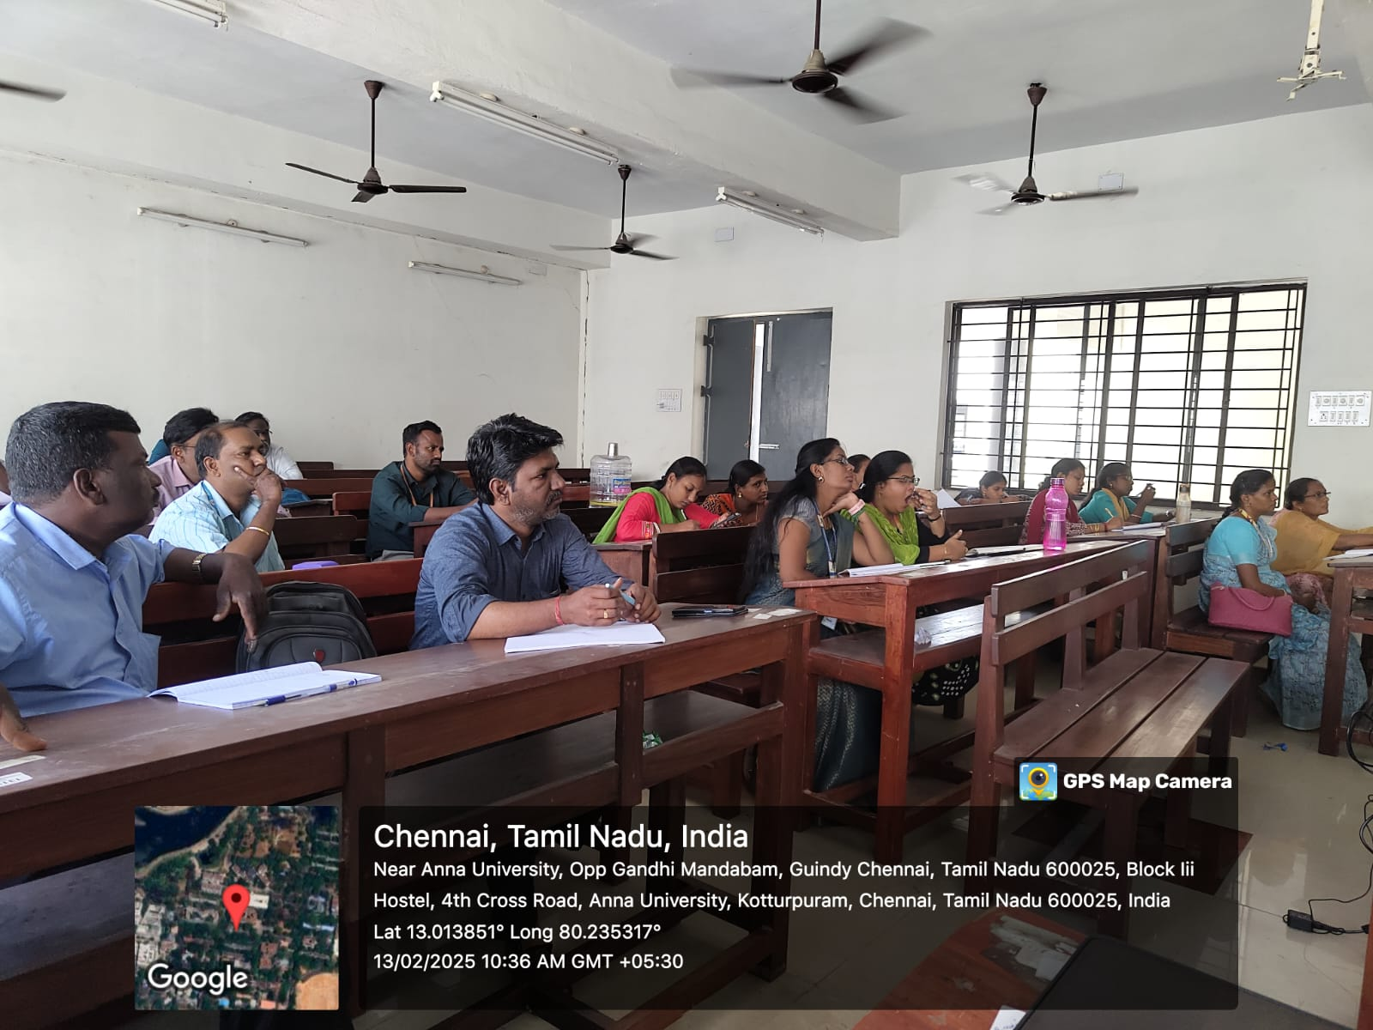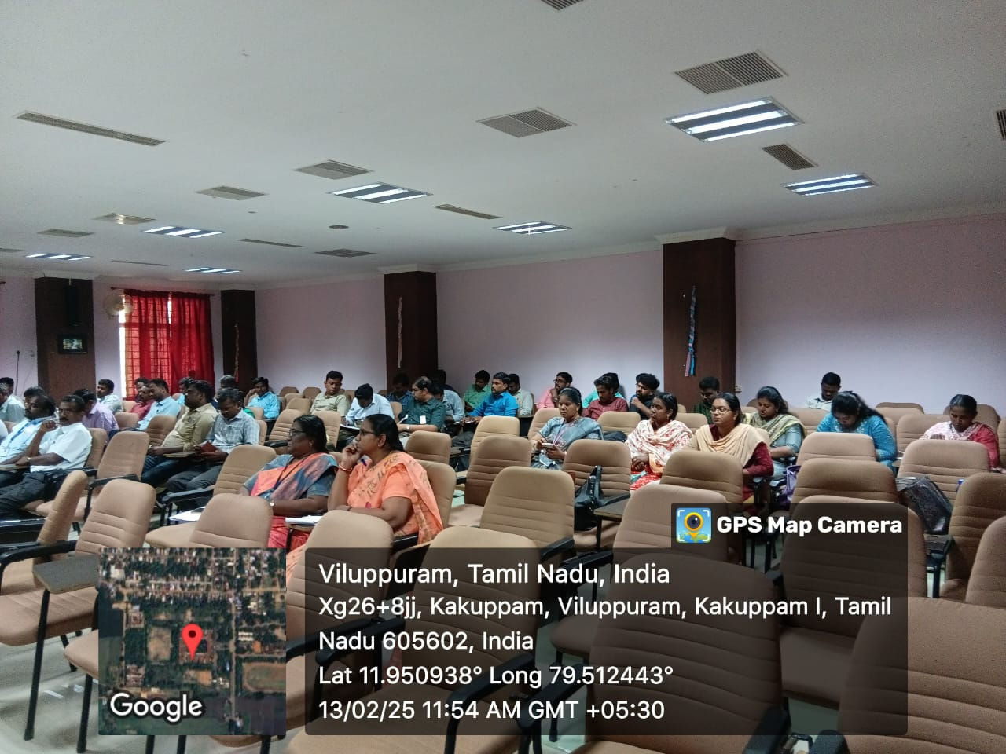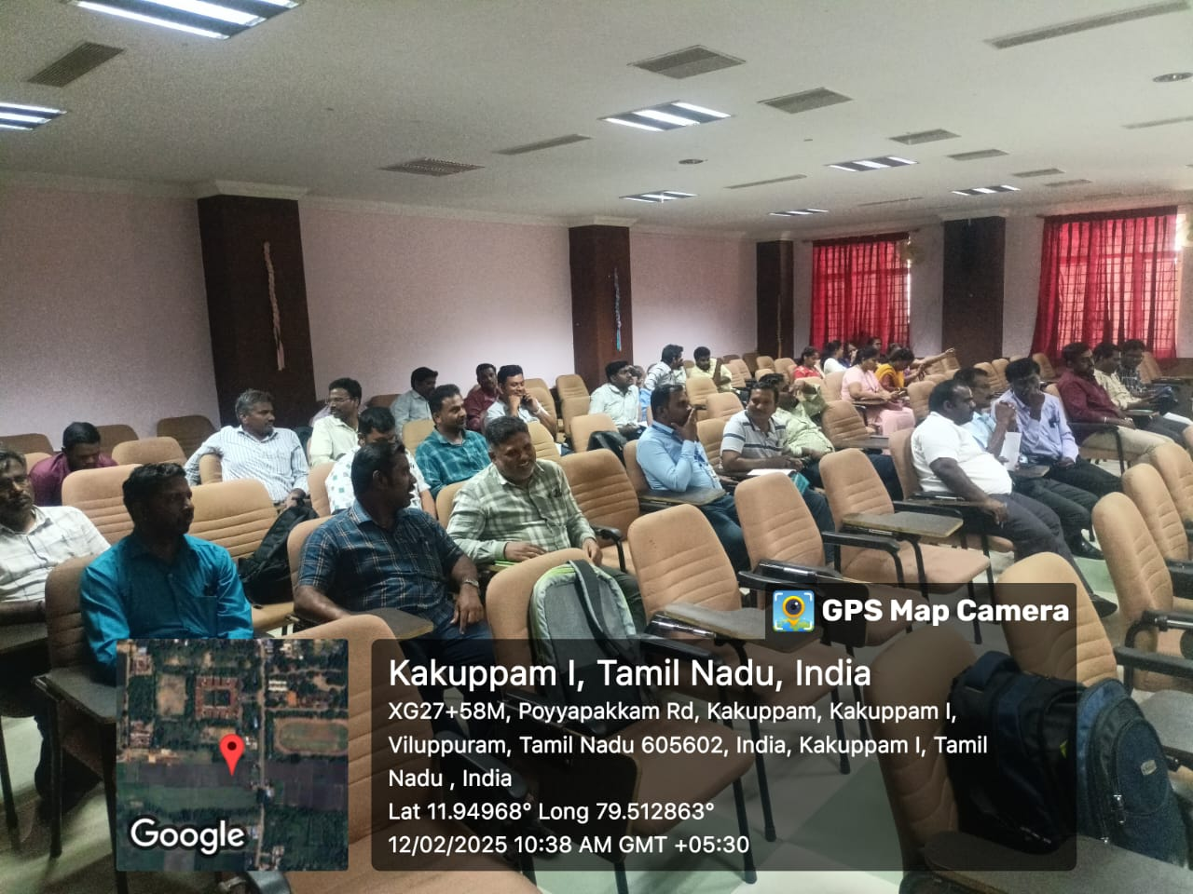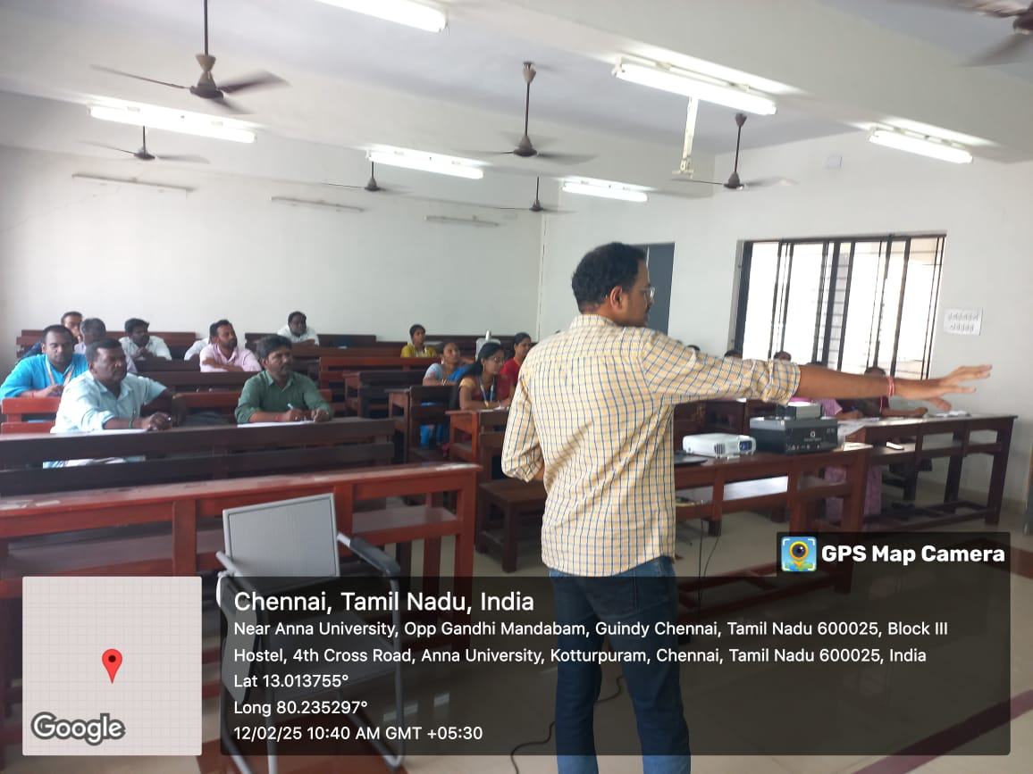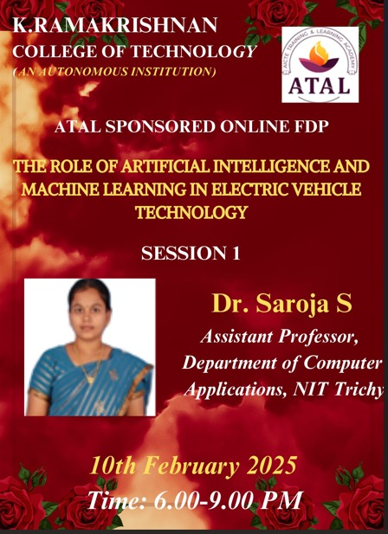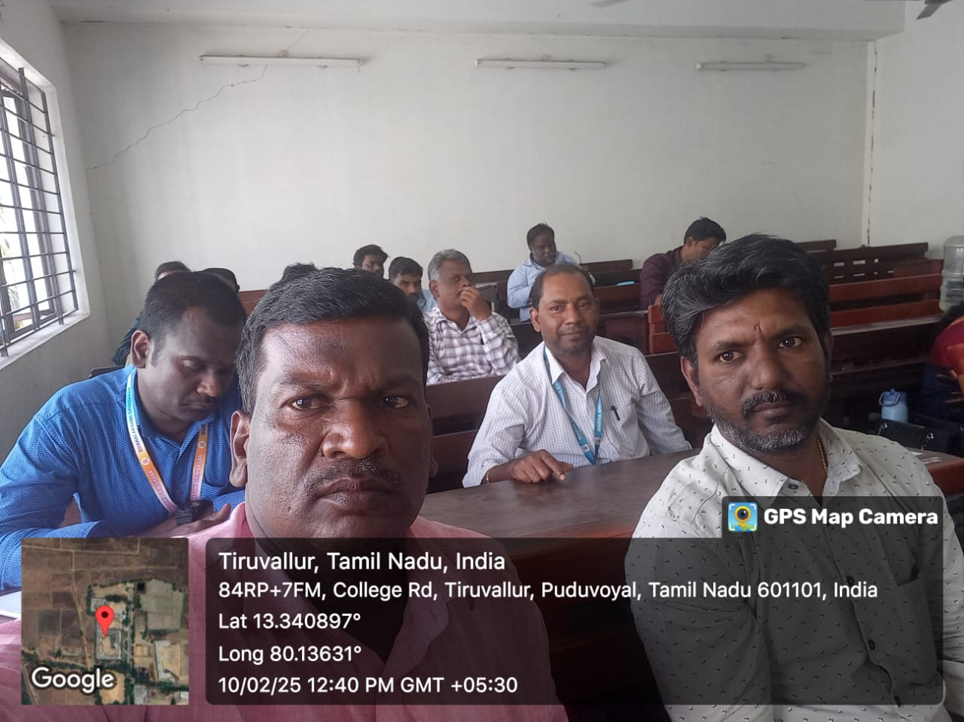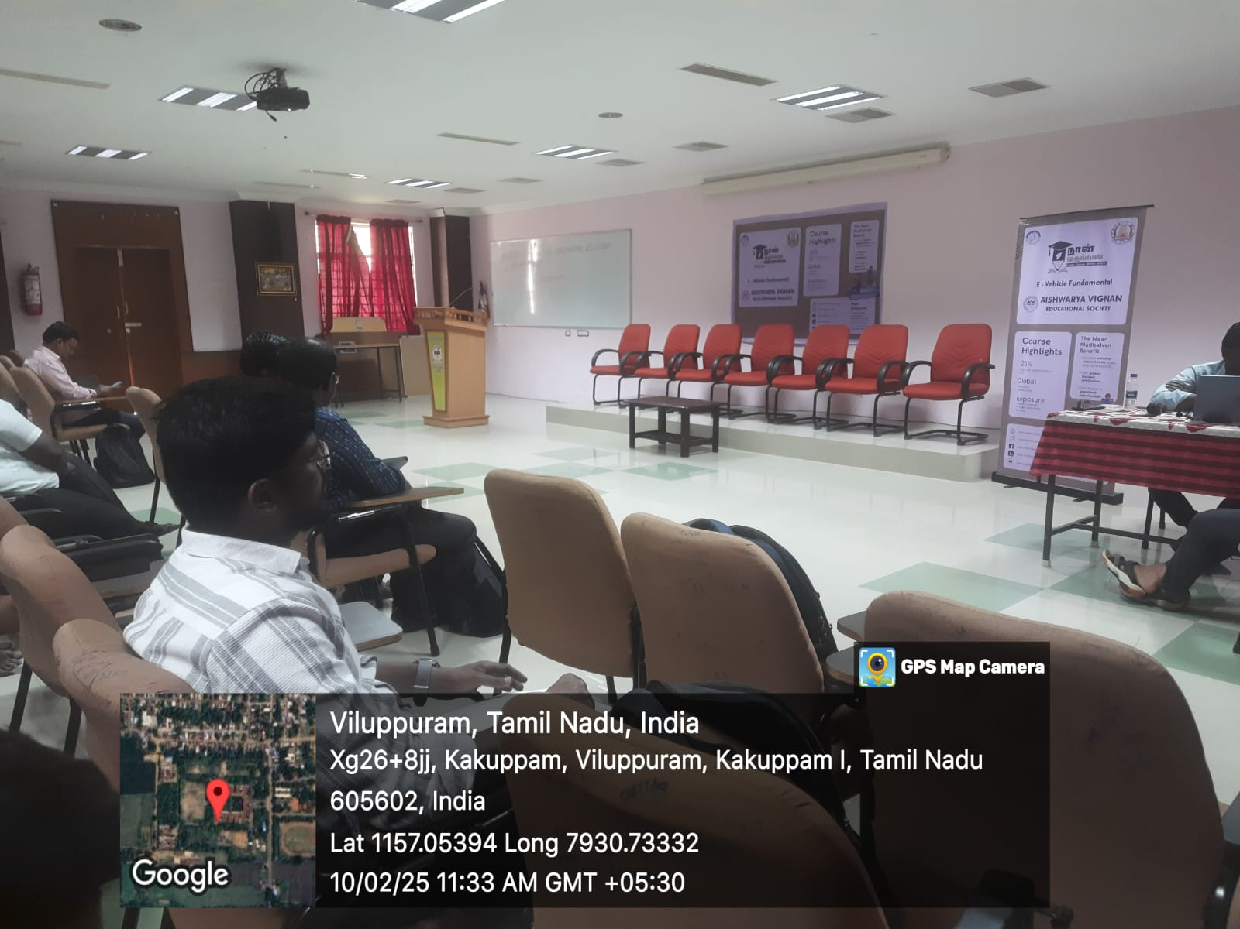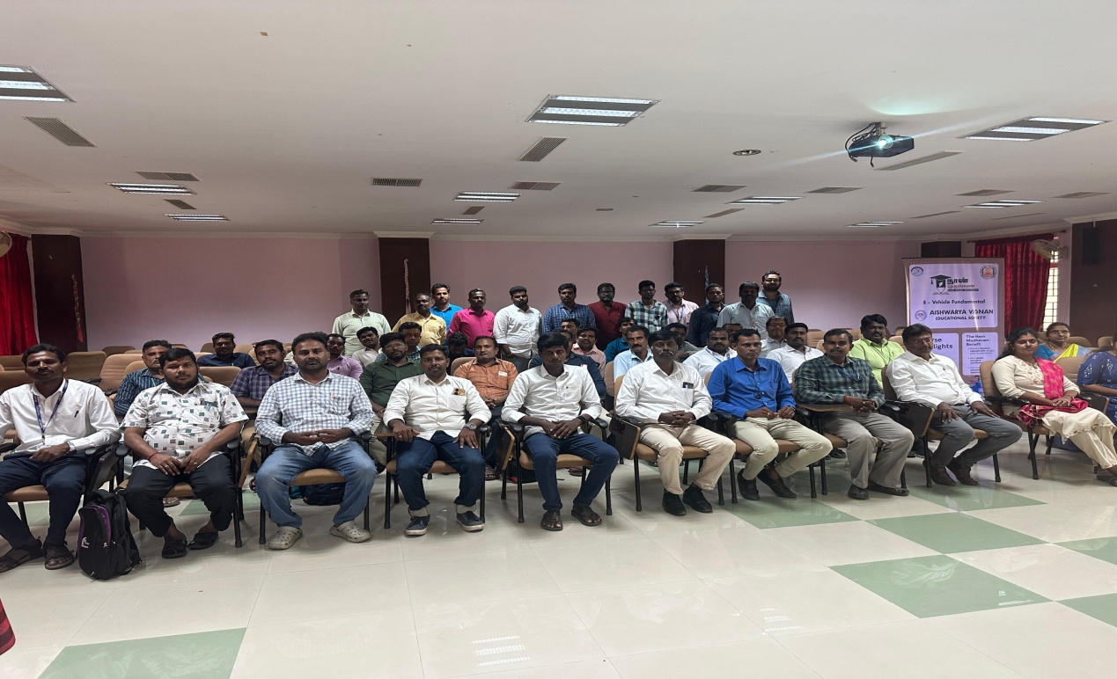

19-02-2025
II Year & III Year Students went to INDUSTRIAL VISIT for “North Chennai Thermal Power Station Stage-I (NCTPS-1)” with the co-ordination of
Mr. S. Ganesh – AP/EEE
Mrs.C.Anusha – AP/EEE
Mr.B.Murali – LI/EEE
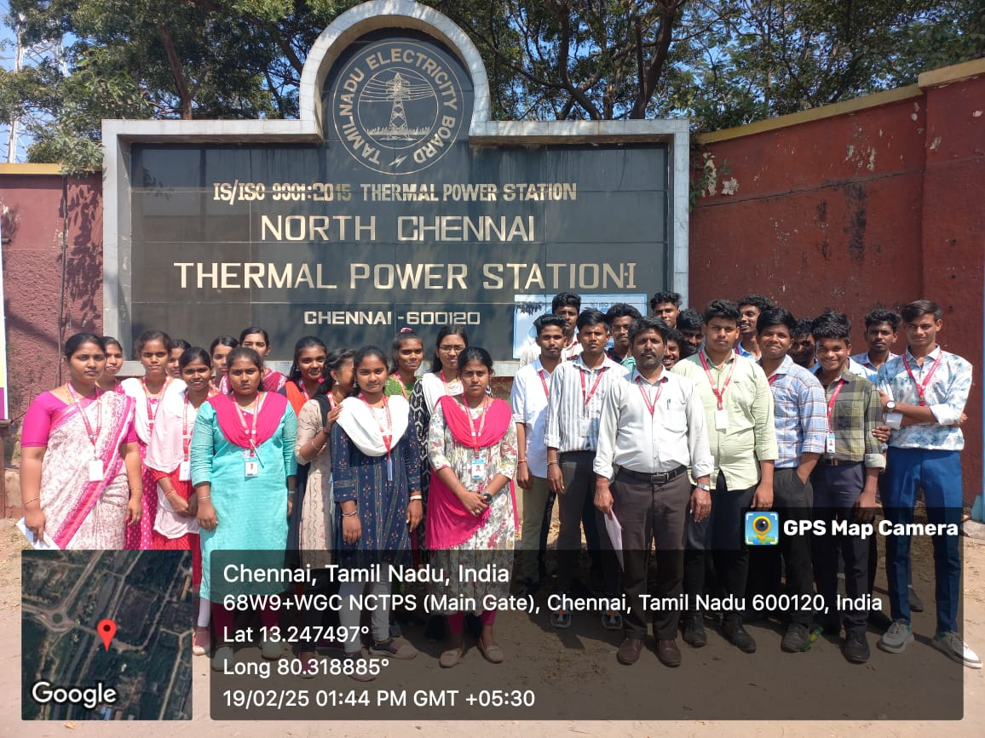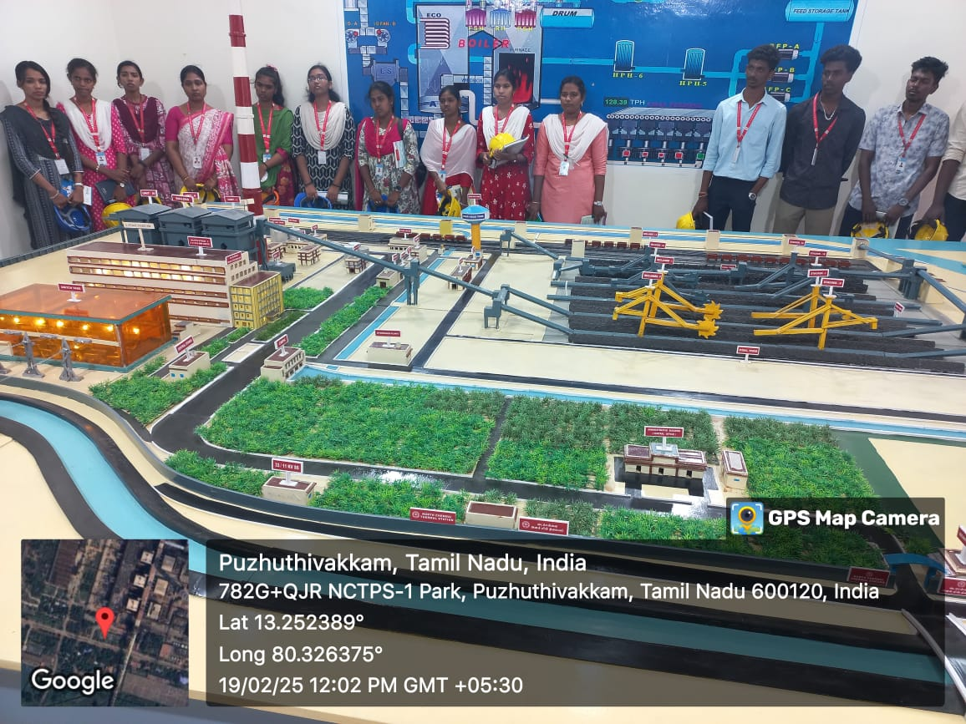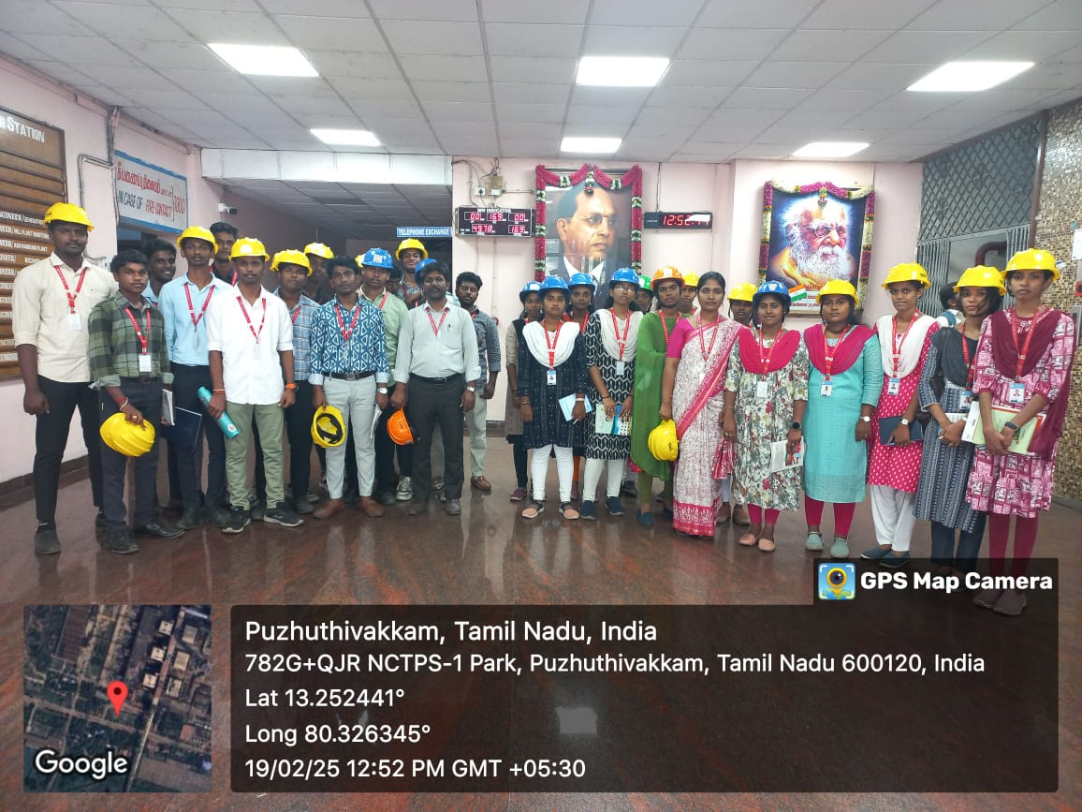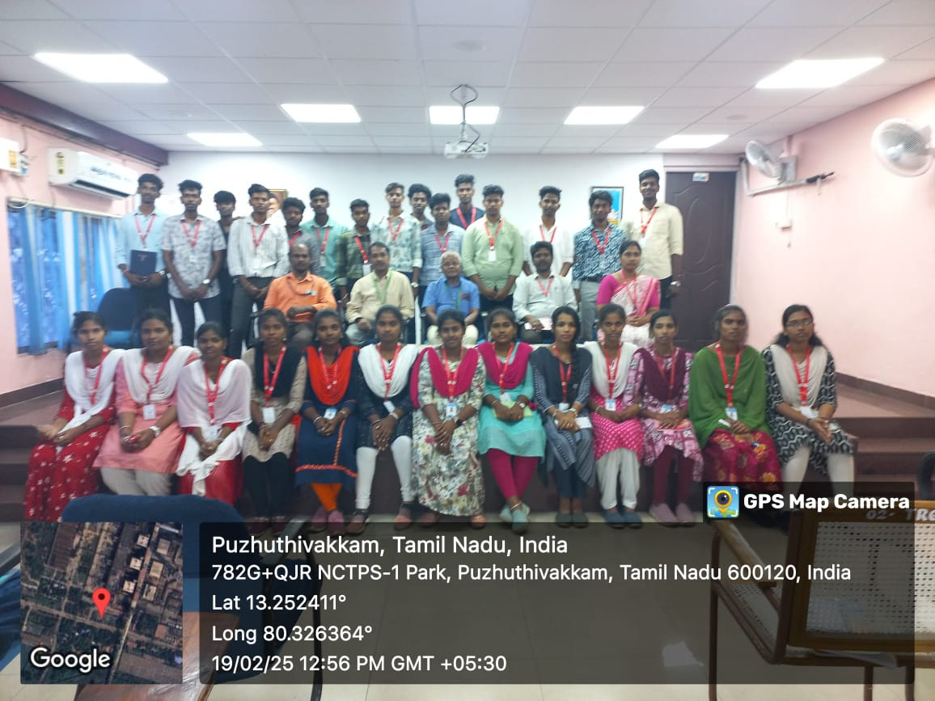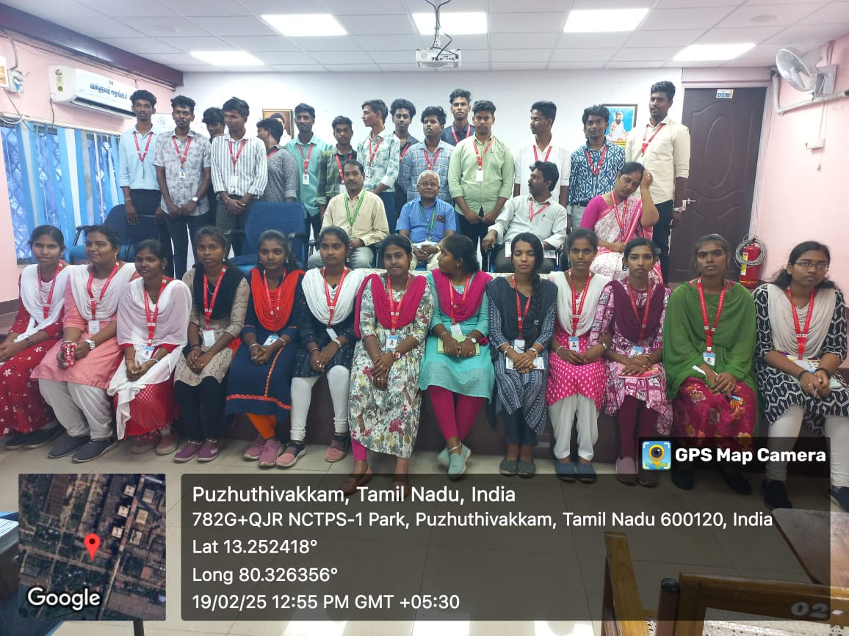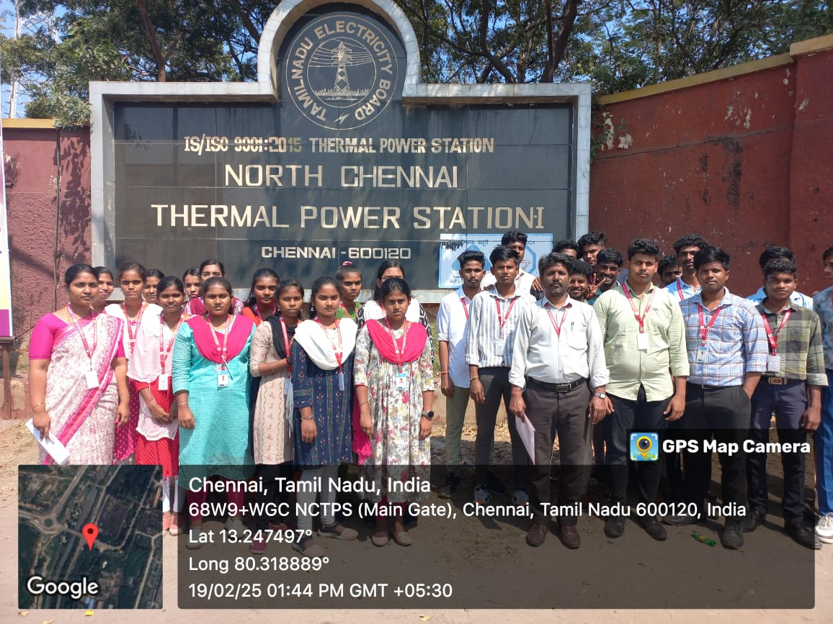

17/02/2025 TO 22/02/2025
FDP organized by ATAL – Sri Ramakrishna Engineering College on “Impact of urban green
spaces in alleviating micro-climate change using geospatial techniques “ attended by

Mrs.M.Shunmuga Sankari – HOD/EEE
Mr.T.Kamalkumar – AP/EEE
Mrs.C.Anusha – AP/EEE
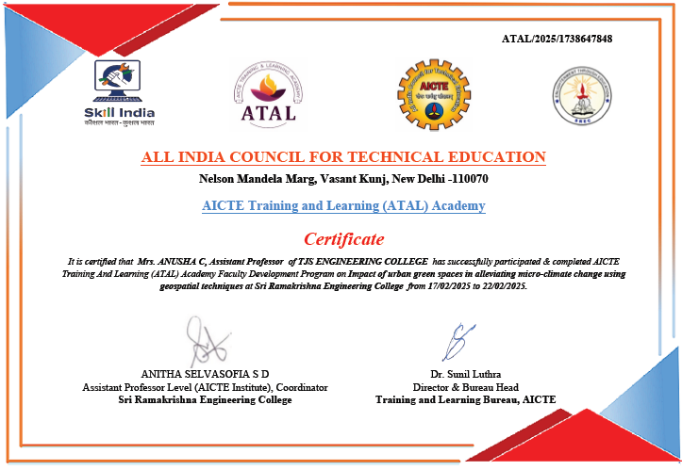
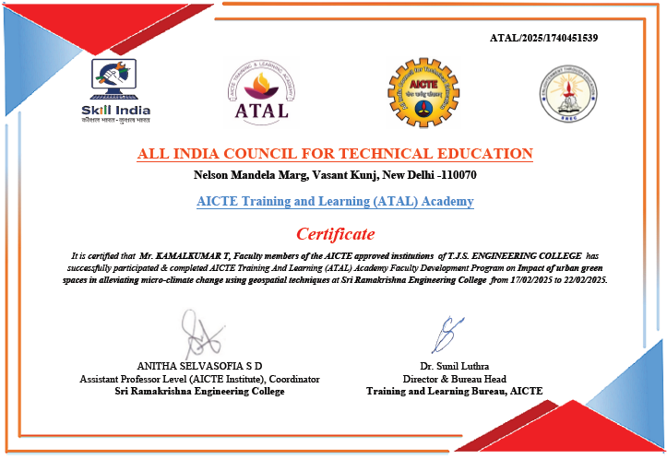
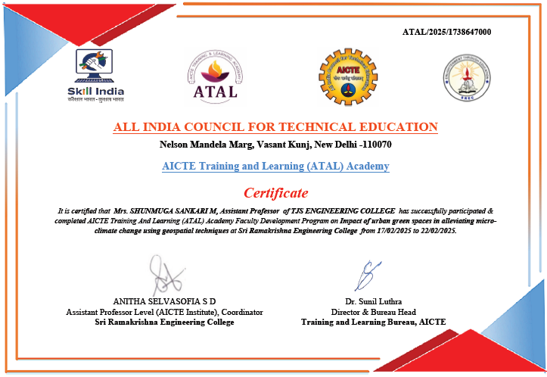
25-02-2025
Naan Mudhalvan Course conducted for III year students on VELAMMAL Engineering College, Thachoor with the co-ordination of Mr.S.Ganesh – AP/EEE
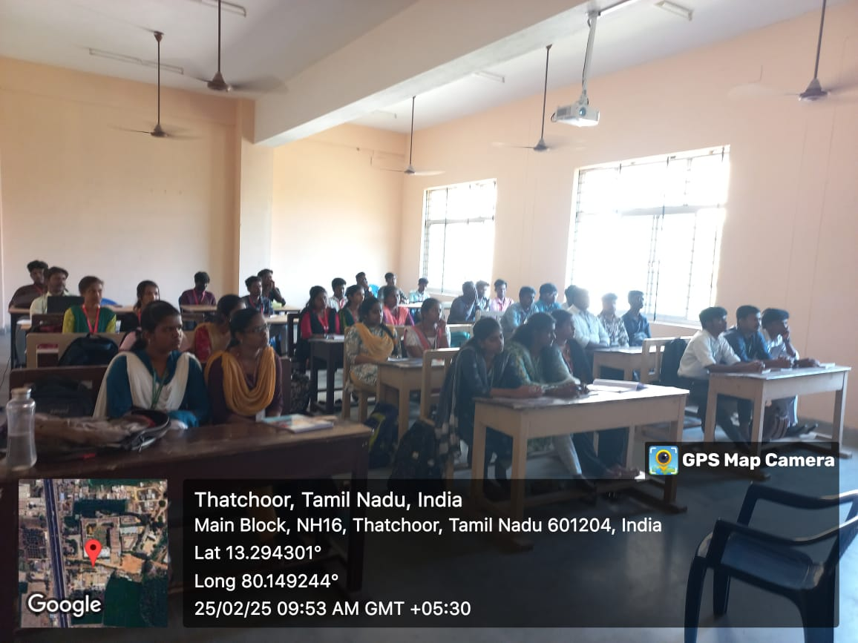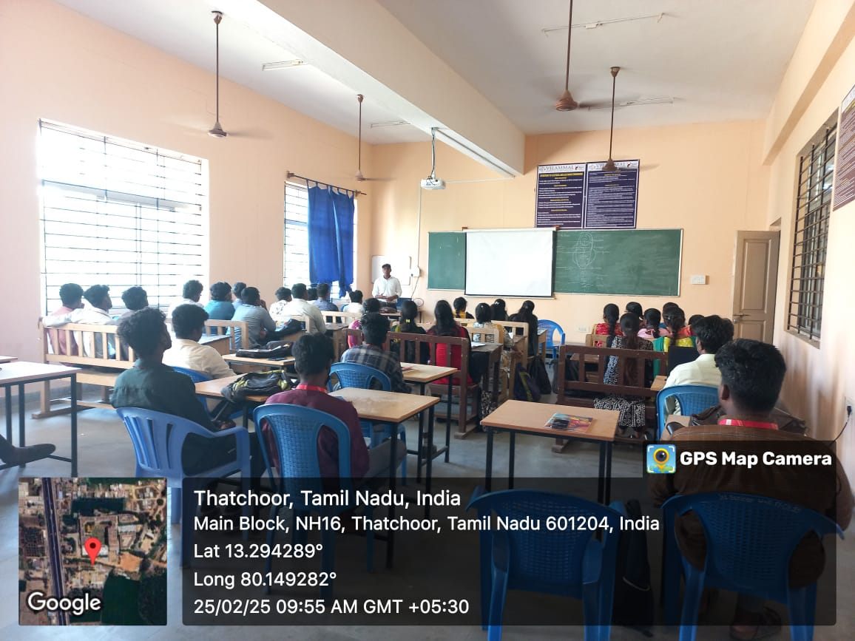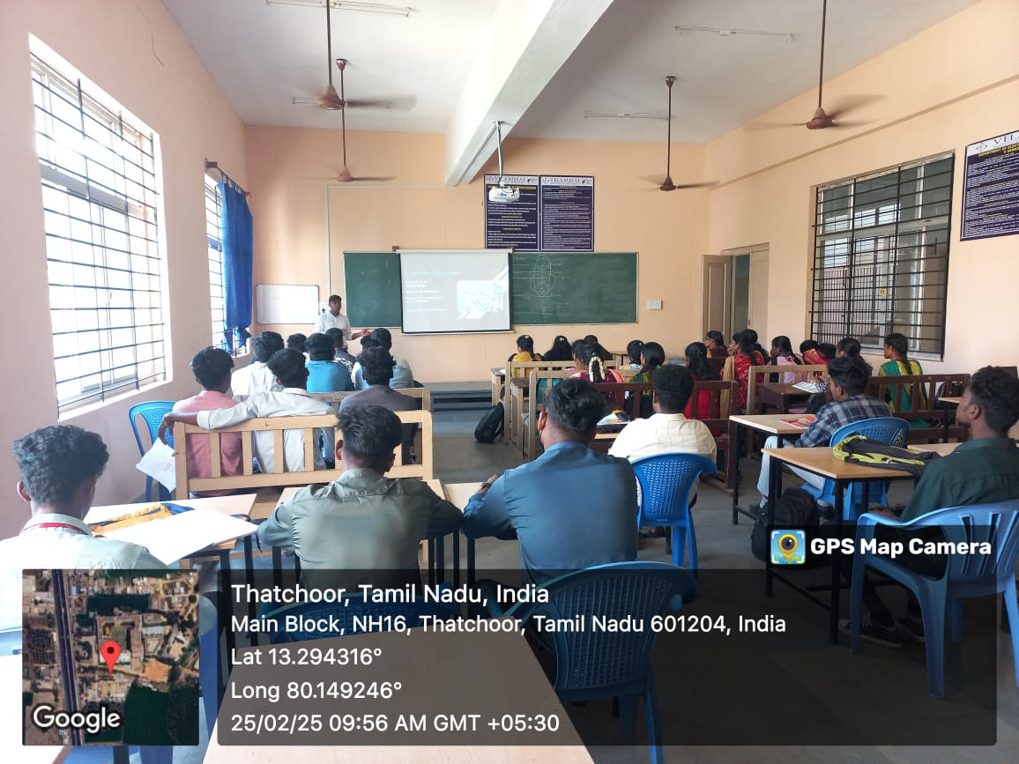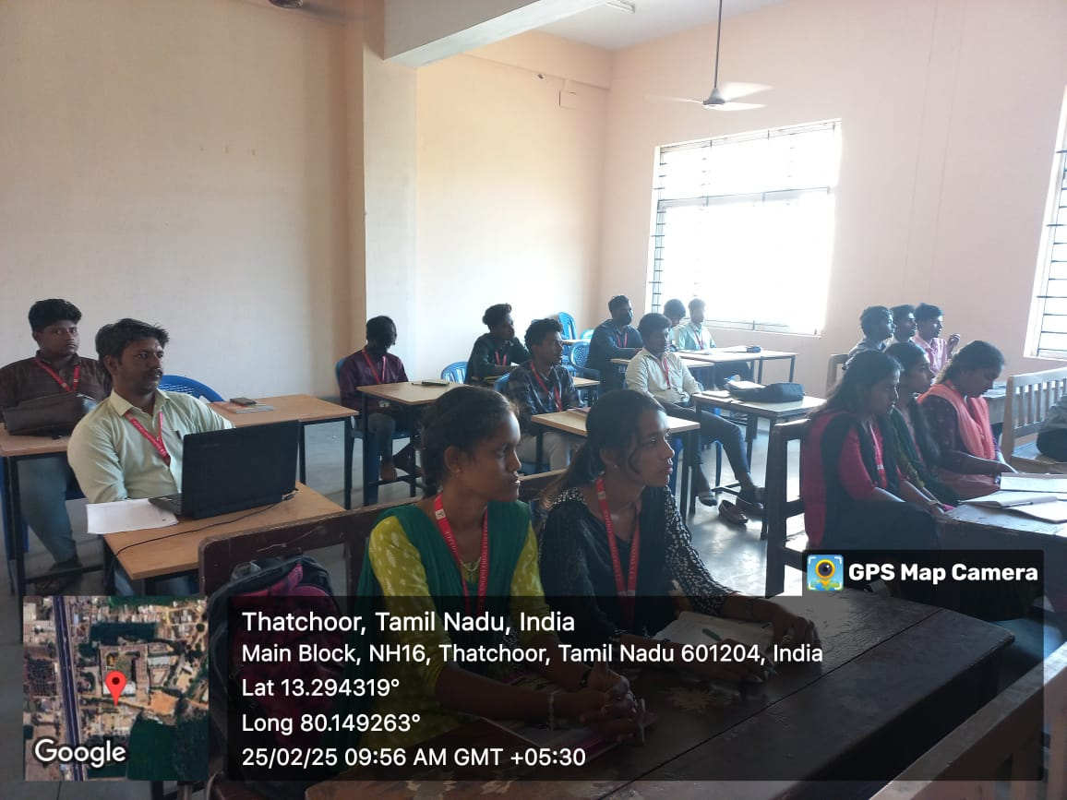

26-02-2025
Naan Mudhalvan Course conducted for II year students on VELAMMAL Engineering College, Thachoor with the co-ordination of Mr.M.Arjunkumar-AP/EEE
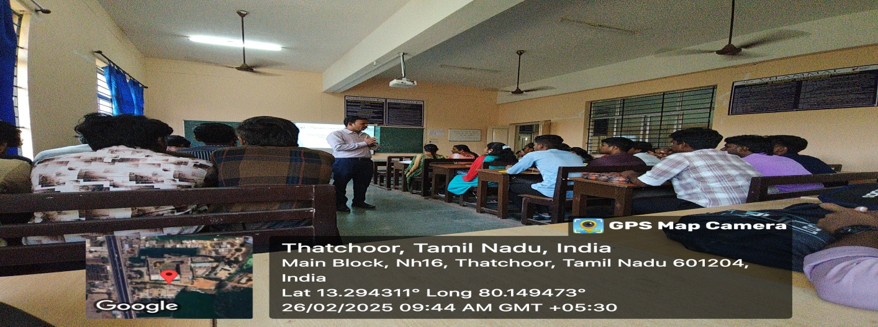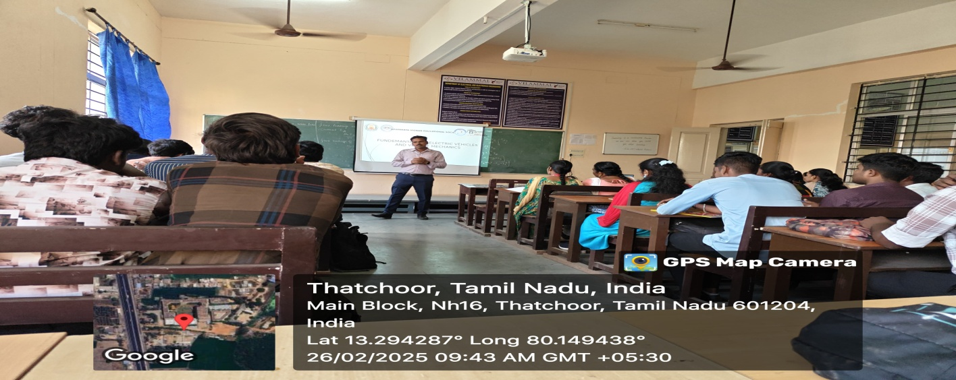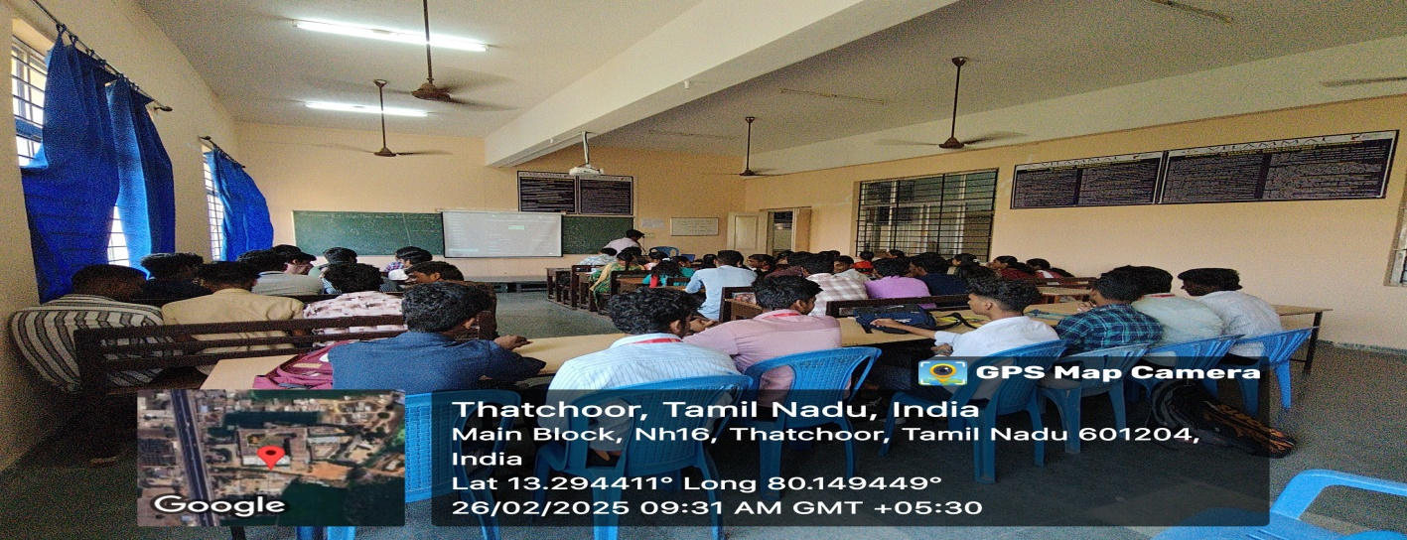

26-02-2025
Alumni meeting arranged for the II & EEE students by
Thirukumaran P (112815105308)
Alstom Transport India Private Limited Company
Senior Engineer

Akash D (112815105301)
Business
Foods and Beverages
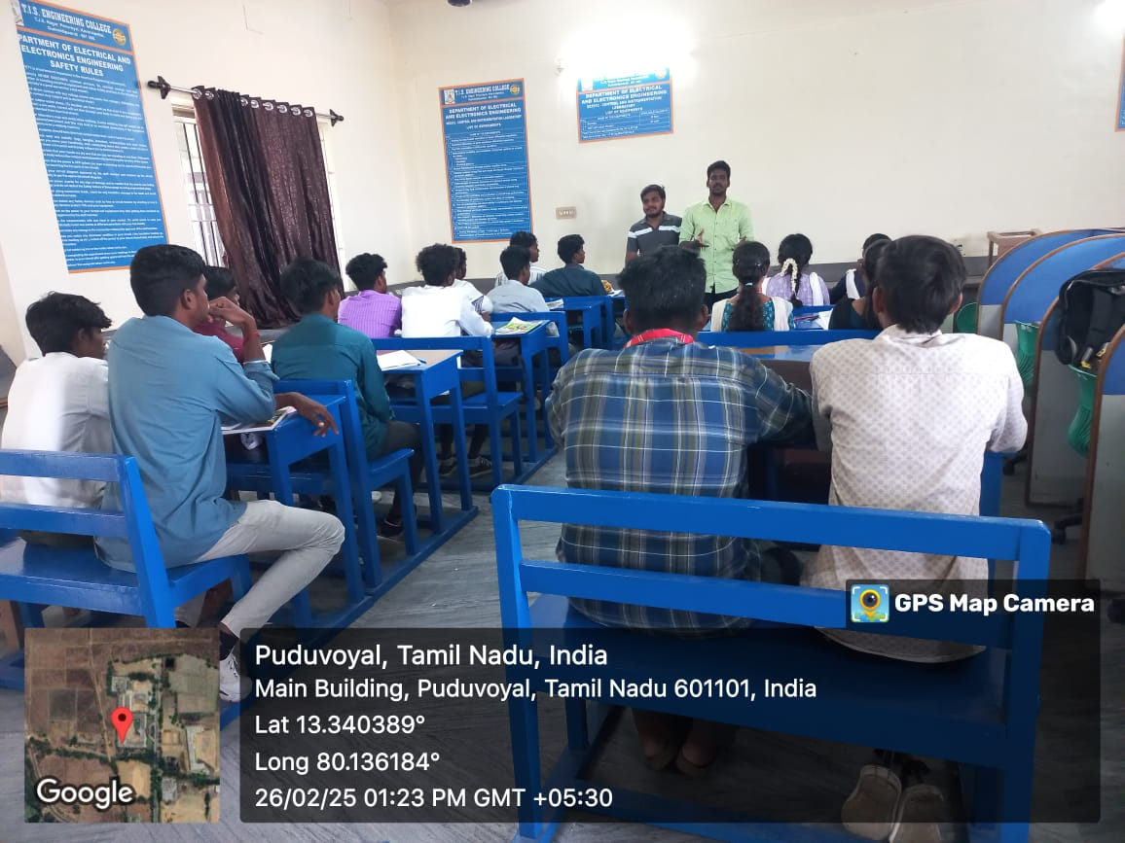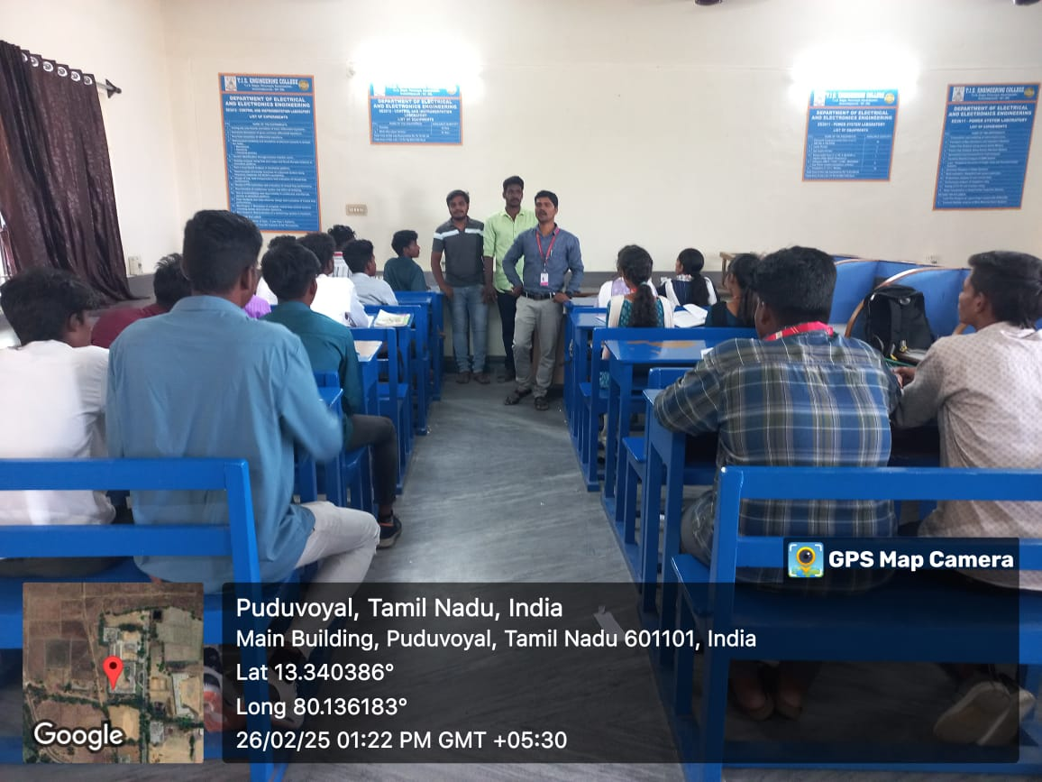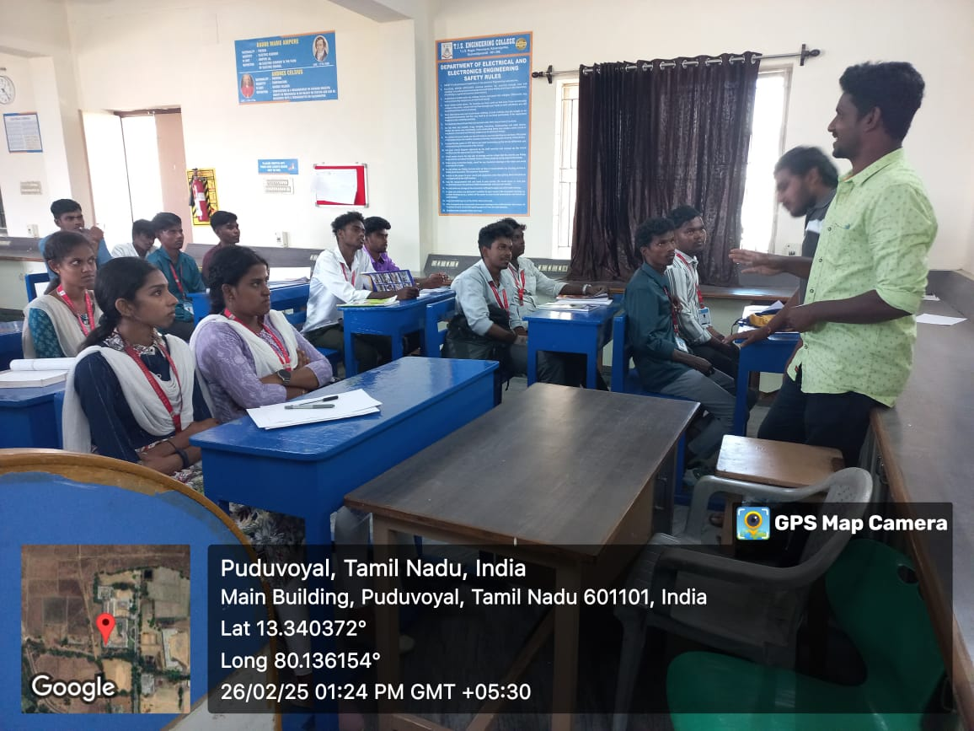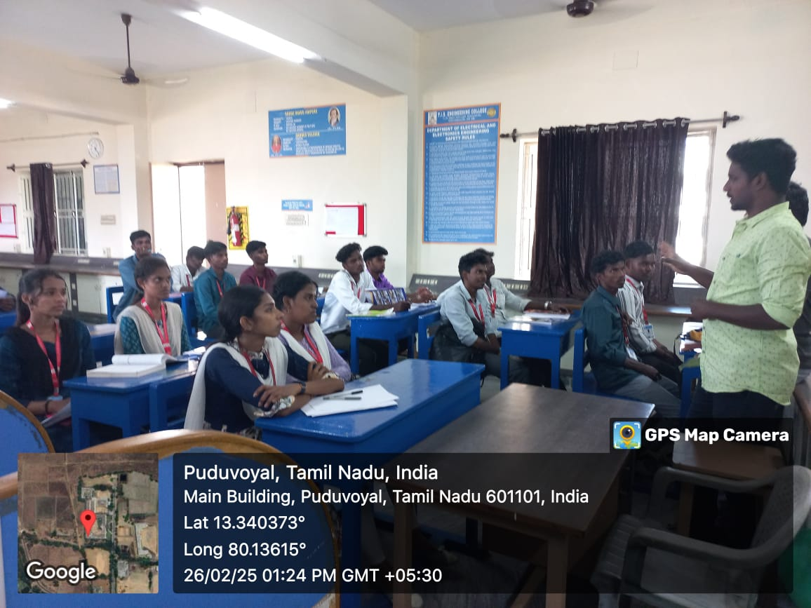

27-02-2025
Industrial Visit for the students of the II, III year to vist the Adani Port,Kattupalli with the co-ordination of following faculties,
- Mrs.M.Shunmuga Sankari – HOD/EEE
- Mr.T.KAMAL KUMAR – AP/EEE
- Mr.M.ARJUNKUMAR - AP/EEE
- Mrs.C.Anusha – AP/EEE
- Mr.B.Murali – LI/EEE
- Mr.K.Shanmugaraj - LI/EEE
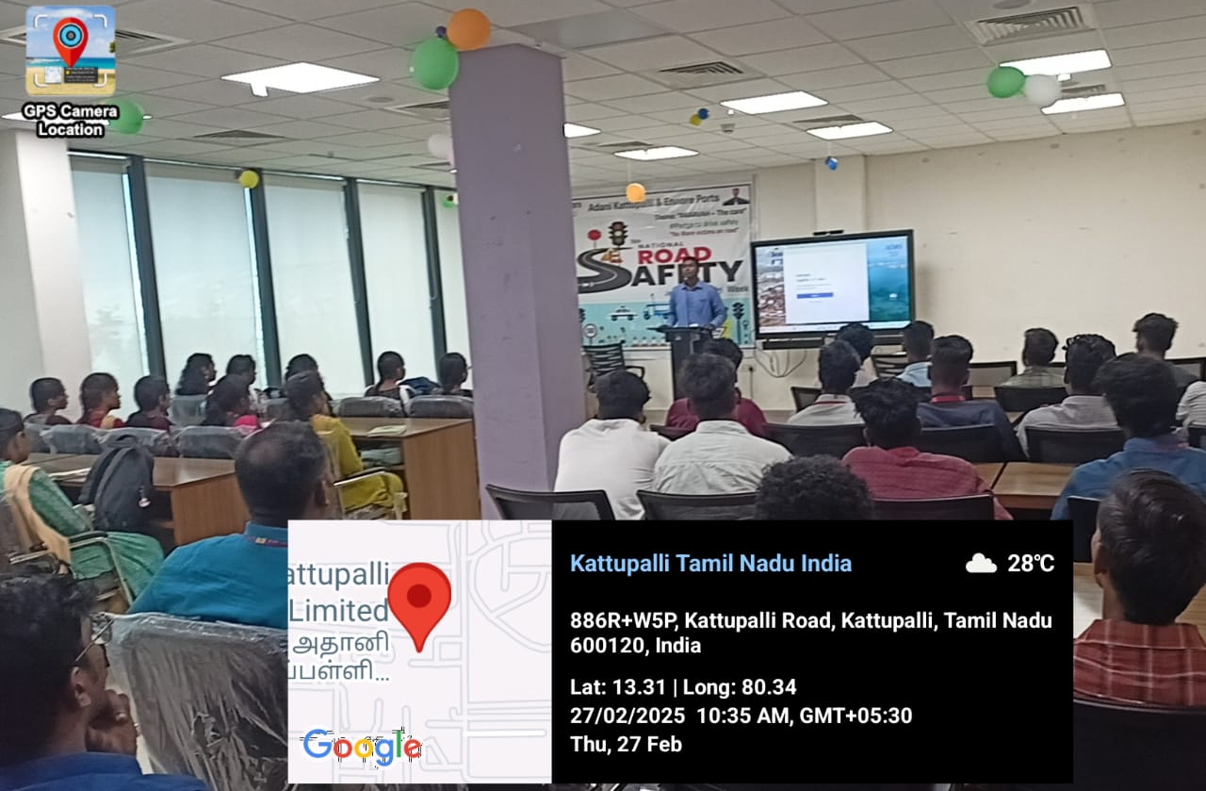
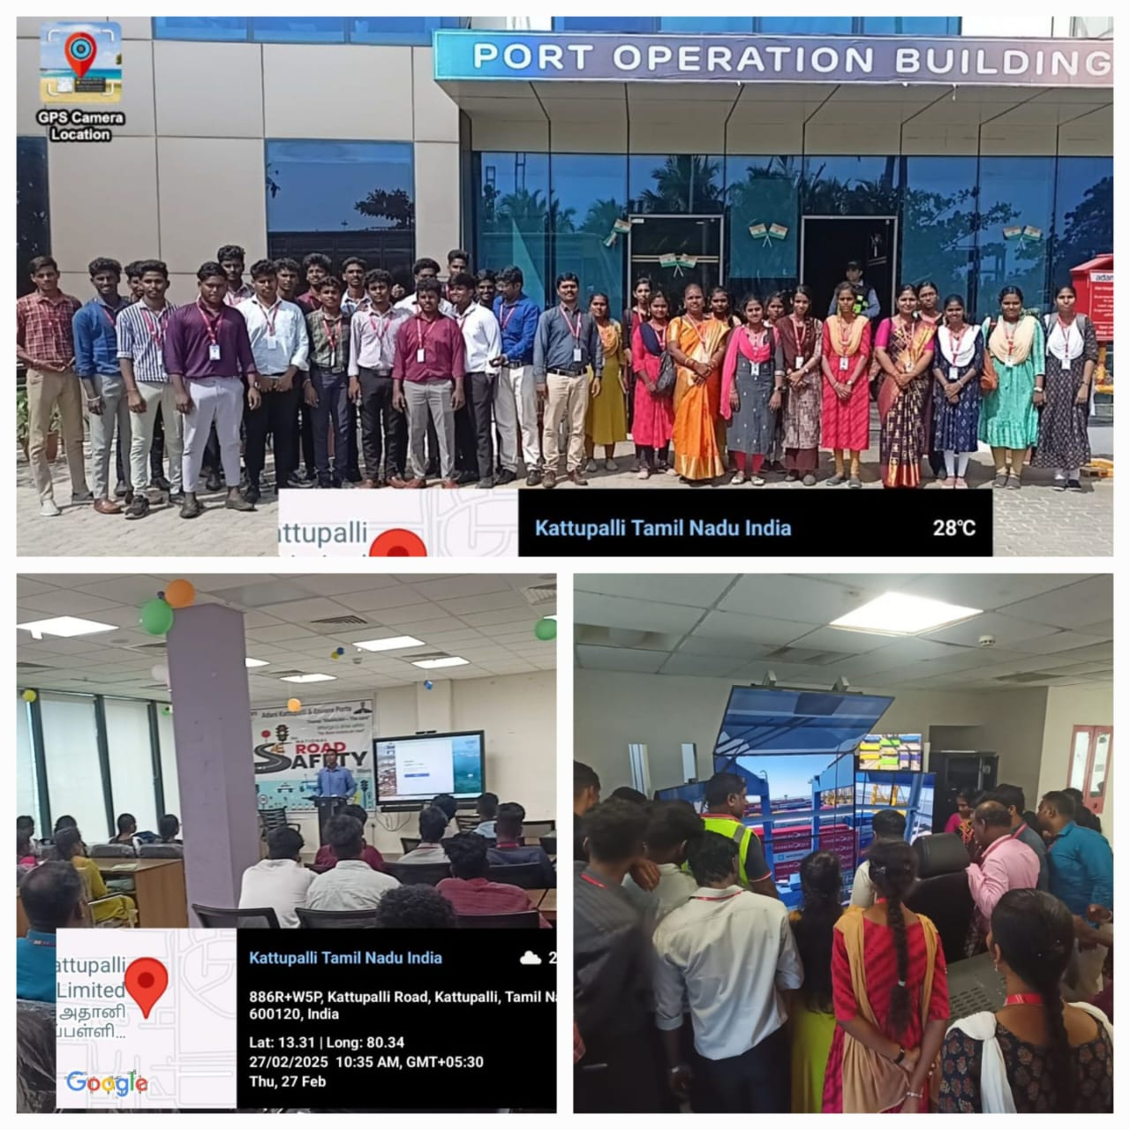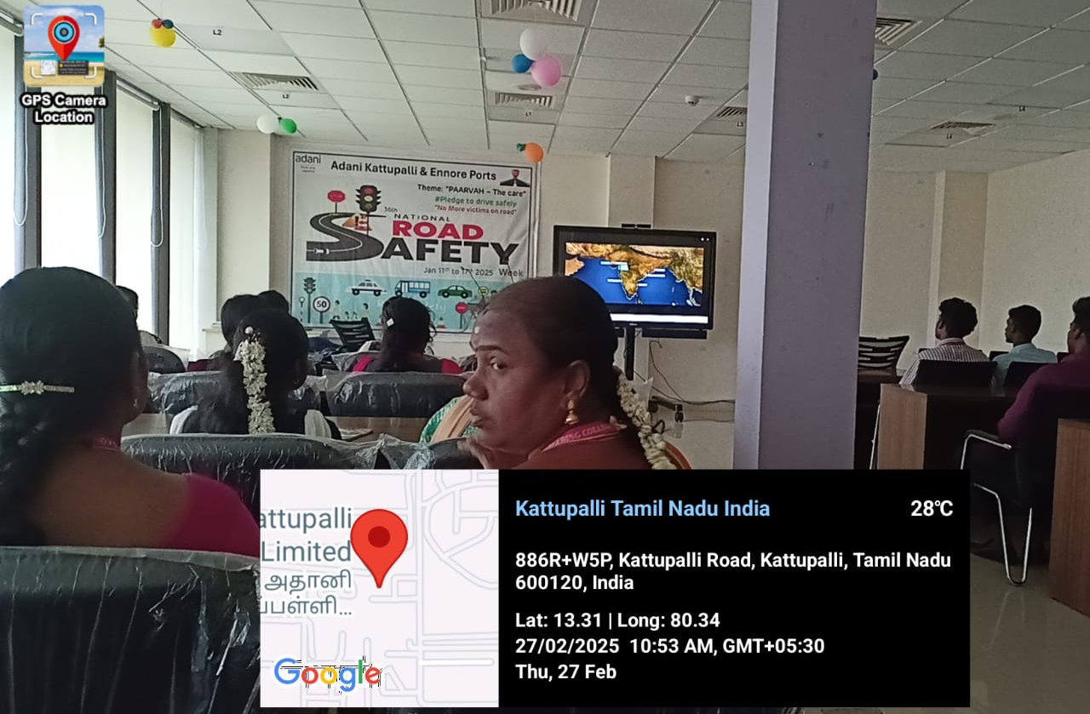

28-02-2025
The following students from the II year has been participated in INVENTEC PROJECT EXPO organized by Gojan School of Business and Technology,Redhills & won 1st Price
- Kamesh.G (112823105013)
- Perarasu.K (112823105016)
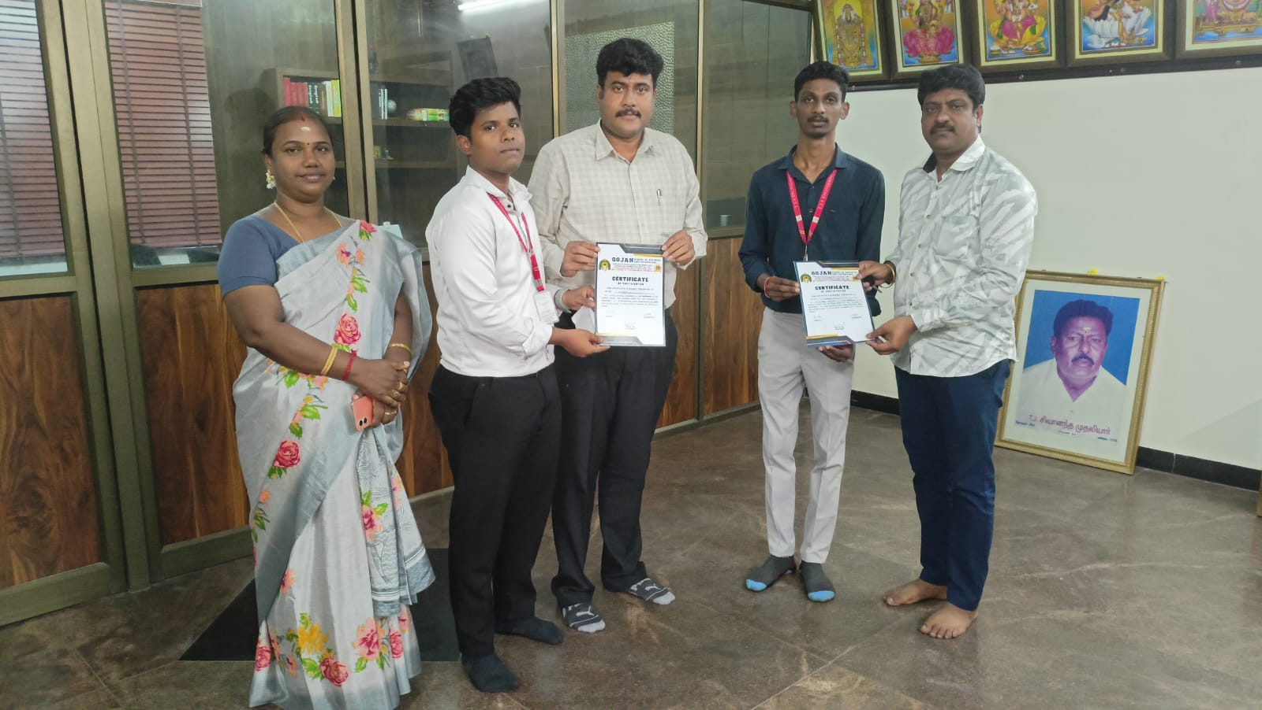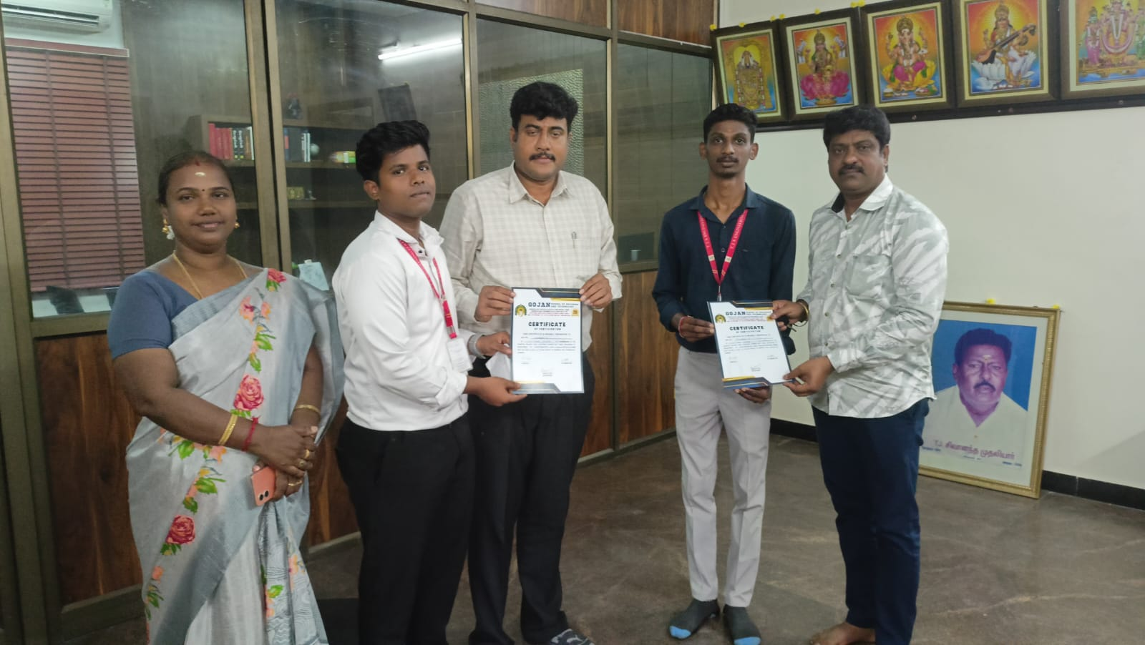
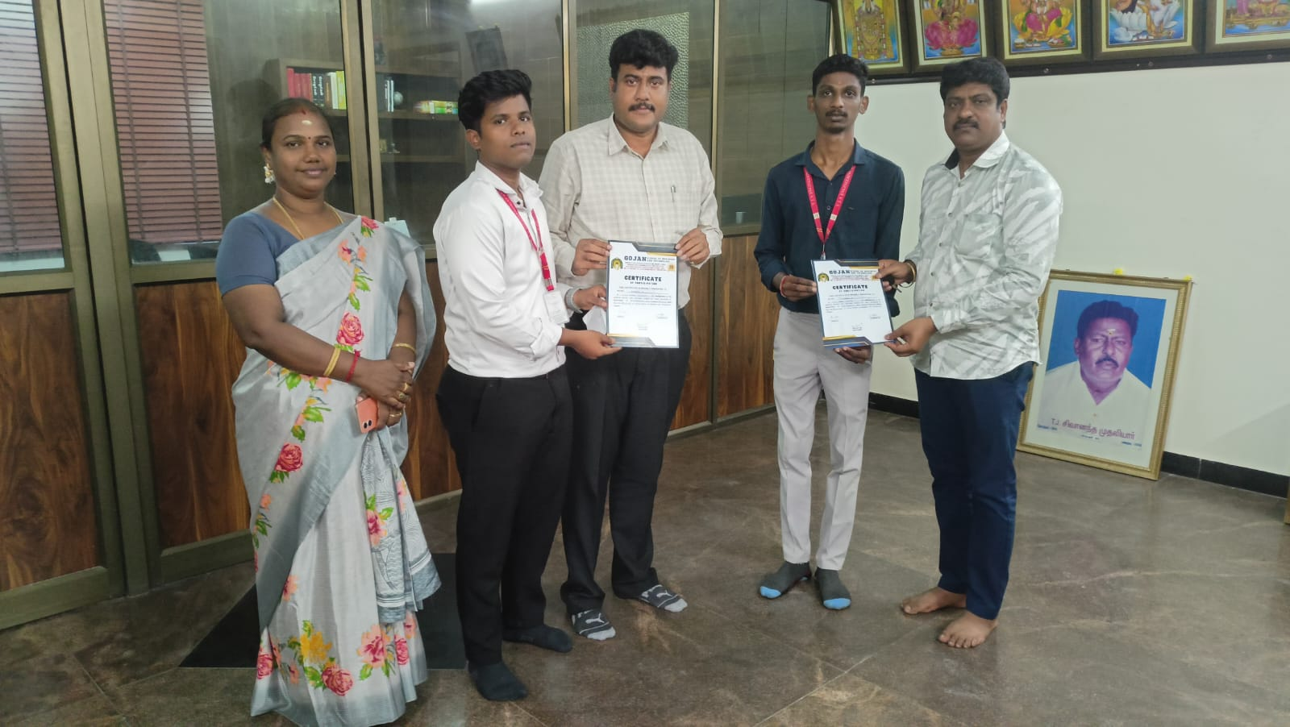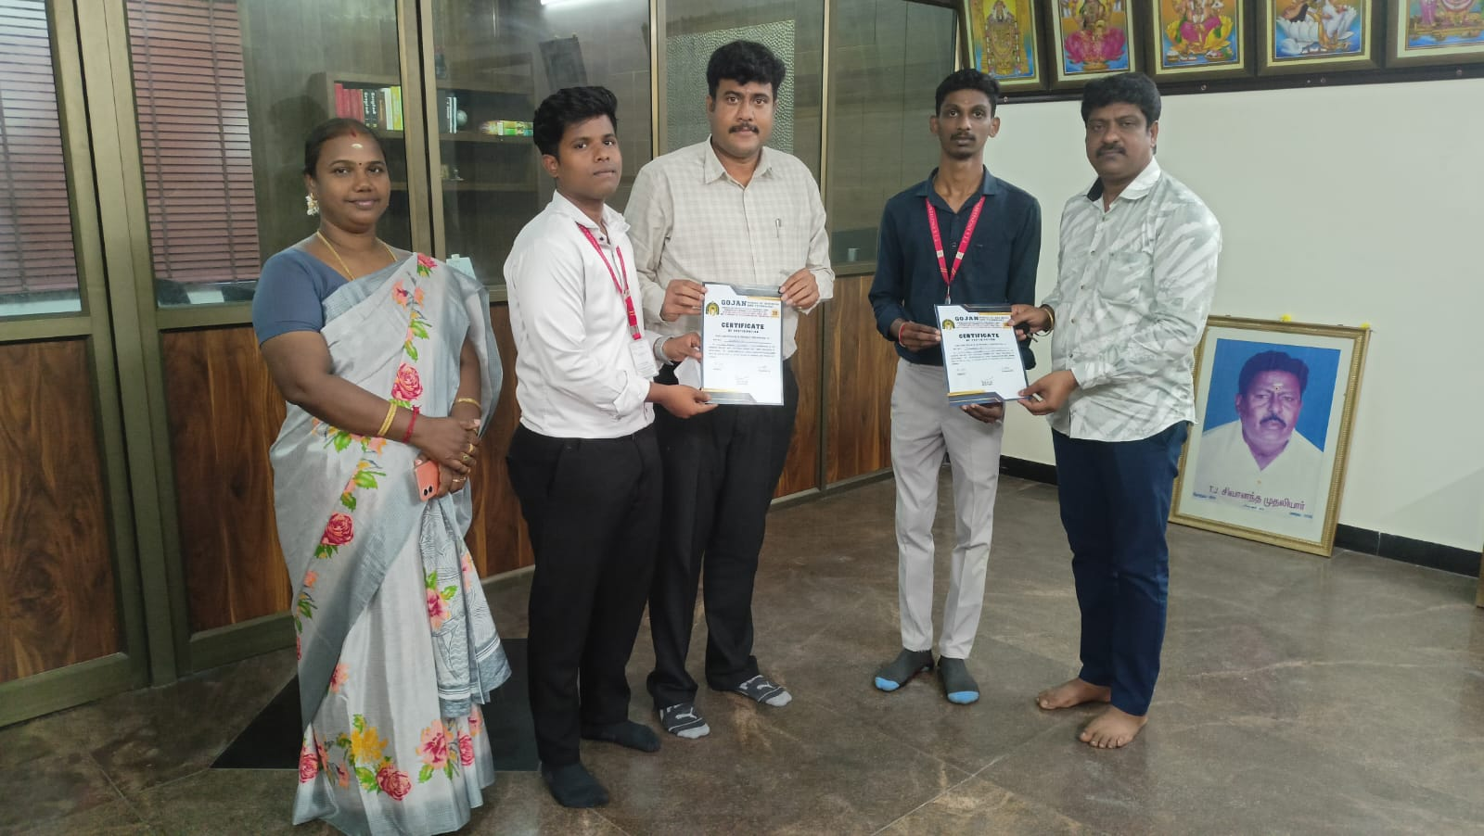

05-03-2025
Naan Mudhalvan Course conducted for II year students on VELAMMAL Engineering College, Thachoor with the co-ordination of Mr.M.Arjunkumar– AP/EEE

11-03-2025
Naan Mudhalvan Course conducted for III year students on VELAMMAL Engineering College, Thachoor with the co-ordination of Mrs.C.Anusha– AP/EEE

